An AI Powered Intrusion Detection and Breach Analysis System



Submitted by:
Mbongeni CM Ncube
{N02219851W}

Supervisor:
Mr. W Mapenduka

A REPORT SUBMITTED TO
The Department of Computer Science at the National University of Science and
Technology in partial fulfilment of the requirements for the degree of
BACHELOR OF SCIENCE (HONS) COMPUTER SCIENCE
Faculty of Applied Sciences

DECLARATION OF ORIGINALITY

I declare that this report entitled “AN AI POWERED INTRUSION DETECTION & BREACH ANALYSIS SYSTEM”
is my own work except as cited in the references. The report has not been accepted for
any degree and is not being submitted concurrently in candidature for any degree or
other award.

Student’s Signature : ......................................................…

Supervisor’s signature : ..................................................…

Date : ................................................

ACKNOWLEGEMENTS

I would like to thank God for the blessings of life. My gratitude also extends to my
supervisor Mr W. Mapenduka for assisting with my project. He guided, corrected and
helped me to come up with ideas on how to conduct this project. I would also love to
thank my family and friends whom also contributed on helping me with some of the
concepts covered in this project.

ABSTRACT

The rapid escalation of cyber threats in modern networked environments has exposed the limitations of traditional security mechanisms, which often fail to detect, interpret, and respond effectively to sophisticated and evolving attacks. This project proposes the development of an AI-Powered Network Intrusion Detection and Breach Analysis System that combines the power of machine learning (ML) and explainable artificial intelligence (XAI) to enhance cyber defense capabilities. The system will monitor and analyze network traffic and system logs to detect intrusions in real time, classify different types of cyberattacks, and conduct detailed breach analyses to determine how attacks occur, which vulnerabilities are exploited, and where they originate. Through the integration of advanced ML algorithms, the system will continuously learn from new data and adapt to emerging threat patterns, improving accuracy and resilience over time.

Unlike conventional intrusion detection systems that merely issue alerts, this system will generate comprehensive forensic reports summarizing attack vectors, paths, and potential mitigations. The inclusion of XAI techniques such as SHAP and LIME will ensure transparency, allowing cybersecurity analysts to interpret and trust model decisions while facilitating more informed incident response. By bridging the gap between automated detection and human understanding, the project aims to establish a proactive, intelligent, and interpretable cybersecurity framework. The resulting system will support timely and data-driven decision-making, reduce false positives, and strengthen network resilience against both known and zero-day attacks.

CHAPTER 1 : INTRODUCTION

1.0 INTRODUCTION

In the contemporary digital era, cybersecurity has emerged as one of the most critical challenges confronting organisations, governments, and individuals. The exponential growth of interconnected systems, combined with the increasing sophistication of cyberattacks, has heightened the need for advanced and adaptive security mechanisms capable of safeguarding sensitive data and network infrastructures. Traditional security mechanisms often rely on static, rule-based systems that are effective against known threats but fail to detect and respond to novel, complex, or evolving attacks (Kim et al., 2020).

Artificial Intelligence (AI) and Machine Learning (ML) have proven to be transformative technologies in cybersecurity, providing intelligent, data-driven methods for detecting, classifying, and mitigating cyber threats. Unlike conventional intrusion detection systems that merely flag anomalies, AI-powered systems can trace attack origins, identify vulnerabilities, and generate actionable insights. This research seeks to develop an AI-powered Intrusion Detection and Breach Analysis System capable of identifying, analysing, and explaining network breaches through explainable artificial intelligence (XAI) mechanisms.

The system’s objective is not only to detect threats in real time but also to provide forensic-level understanding of how breaches occur, thereby enabling proactive security responses.

  - BACKGROUND OF STUDY

The constant evolution of cyber threats has exposed the limitations of traditional intrusion detection and prevention systems (IDPS). These systems typically fall into two categories: signature-based and anomaly-based. Signature-based systems identify threats by comparing network activity to known attack patterns, making them reliable for detecting familiar intrusions but ineffective against new or modified attacks (Sarker et al., 2020). Conversely, anomaly-based systems monitor deviations from normal behaviour but often suffer from high false-positive rates, especially in complex, high-traffic environments (Vinayakumar et al., 2019).

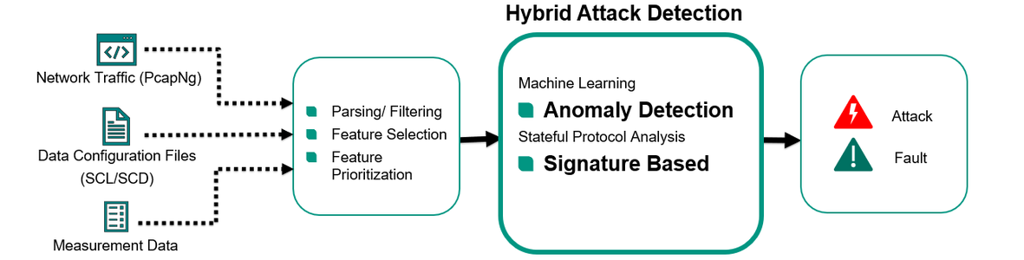
AI and ML techniques have become increasingly prominent in addressing these limitations. By analysing large-scale network traffic data, AI-based systems can autonomously learn patterns of both benign and malicious activities. Such systems adapt dynamically, improving detection accuracy while minimising human intervention. For example, Deep Learning models—including Convolutional Neural Networks (CNNs) and Recurrent Neural Networks (RNNs)—can model intricate temporal and spatial features within traffic data, allowing them to identify sophisticated attack behaviours (Kim et al., 2020). Similarly, ensemble methods such as Random Forests and Gradient Boosting provide robustness against noise and improve generalisability across datasets (Ahmad et al., 2021).

Despite these advances, there remains a critical gap between intrusion detection and breach analysis. Most systems stop at alert generation and fail to provide contextual insights into how an attack was executed, which vulnerabilities were exploited, or how the compromise propagated through the network (Islam et al., 2023). The proposed research addresses this deficiency by integrating explainable AI (XAI) and forensic analysis to move from simple alerting to comprehensive root-cause evaluation, offering actionable intelligence for security teams.

1.2 PROBLEM STATEMENT

Traditional intrusion detection systems are primarily reactive; they focus on identifying potential attacks but lack analytical depth in explaining how and why a breach occurred. This deficiency leaves organisations vulnerable to repeated intrusions exploiting the same weaknesses. Additionally, existing systems struggle to maintain accuracy in detecting rare or low-frequency attacks and to scale effectively in high-volume network environments (Alzubaidi et al., 2024).

Another critical issue lies in the interpretability of AI models. While AI and ML have enhanced detection accuracy, many models—especially deep learning architectures—operate as “black boxes,” making it difficult for analysts to comprehend or trust their decisions. Without interpretability, incident response teams face challenges in justifying automated findings and developing appropriate countermeasures (Islam et al., 2023).

Therefore, there is an urgent need for an intelligent, interpretable, and adaptive system that not only detects network intrusions but also analyses the root causes and provides transparent, actionable insights. This project aims to bridge that gap by integrating AI-driven intrusion detection with explainable breach analysis.

  - AIM

To develop an AI-powered intrusion detection and breach analysis system capable of detecting cyberattacks, tracing their causes, and providing interpretable forensic insights for proactive network defence.

  - OBJECTIVES

1. To detect network intrusions in real time using machine learning models.
2. To analyse detected breaches by identifying how each attack occurred, including the vulnerabilities exploited.
3. To generate breach analysis reports summarising attack type, impact, origin, and recommendations for mitigation.

  - ETHICAL CONSIDERATIONS

Given that this study involves the handling of network and system data, strict adherence to ethical and legal principles is vital. Data privacy and confidentiality will be prioritised throughout the project. All network data will be anonymised before analysis to ensure compliance with the General Data Protection Regulation (GDPR) and institutional ethical guidelines (Al-Gburi, Al-Shourbaji & Ameen, 2022).
Access to raw data and system logs will be restricted to authorised personnel. Additionally, the research will use publicly available datasets such as UNSW-NB15, CICIDS2017, and KDD Cup 1999, ensuring no violation of data ownership or privacy. The integration of explainable AI also promotes ethical transparency, enabling analysts to understand and validate the model’s decisions.

  - PROJECT SCOPE

The scope of this research encompasses the design, development, and evaluation of an AI-powered intrusion detection and breach analysis system. The project will employ both supervised and unsupervised learning algorithms—such as Random Forest, Support Vector Machine (SVM), CNN, and Autoencoders—to detect and classify cyberattacks.

Data for training and evaluation will be sourced from public benchmark datasets and simulated environments. The project will focus on common attack categories such as Denial of Service (DoS), brute force, phishing, and data exfiltration. However, advanced attack types such as insider threats or nation-state attacks are beyond the scope of this research.

The developed system will feature a modular architecture integrating Explainable AI components for interpretability, ensuring scalability to large networks and real-time adaptability. The final deliverable will include an operational prototype capable of generating breach analysis reports and visualising attack paths.

  - SIGNIFICANCE OF STUDY

The study is significant for several reasons. Firstly, it contributes to addressing the increasing global threat of cybercrime, which continues to cause extensive financial and reputational damage to organisations (Li et al., 2024). By introducing a system that not only detects but also explains intrusions, this research enhances both technical capability and operational trust in AI-based security systems.
Secondly, the integration of Explainable AI promotes transparency and accountability, aligning with emerging trends in responsible AI deployment within cybersecurity (Choraś et al., 2024). It enables human analysts to interpret AI-generated findings, reducing the risk of blind reliance on automated systems.
Thirdly, the study bridges a crucial gap between academic research and practical application by integrating data-driven analytics with real-time forensic capabilities. The proposed system’s ability to trace root causes and visualise attack sequences offers actionable insights that can significantly improve incident response and resilience.

Lastly, the research supports the development of adaptive, sustainable, and interpretable AI systems that align with long-term cybersecurity objectives, particularly in developing nations where resource-efficient solutions are essential.

  - REPORT OVERVIEW

This dissertation is structured into six chapters:

Chapter 1: Introduction – introduces the research topic, problem statement, objectives, scope, and significance.

Chapter 2: Literature Review – presents a systematic analysis of existing studies using the PRISMA framework, identifying current trends and research gaps in AI-based intrusion detection and breach analysis.

Chapter 3: Methodology – outlines the research design, methodologies (Design Science Research and Agile approach), and justifications for their adoption.

Chapter 4: System Analysis and Design – details the system architecture, diagrams, and functional specifications.

Chapter 5: Implementation and Testing – presents implementation results, testing outcomes, and performance evaluation metrics.

Chapter 6: Conclusion and Recommendations – summarises findings, discusses implications, and suggests future research directions.

  - CONCLUSION

This chapter has established the foundational framework for the study, highlighting the pressing need for intelligent and interpretable cybersecurity solutions. It identified limitations in current intrusion detection systems and articulated how AI and XAI can revolutionise breach detection and analysis. The chapter also defined the study’s aim, objectives, scope, and ethical considerations, establishing a clear trajectory for the subsequent chapters. The next chapter will present a comprehensive literature review, examining existing research and identifying the theoretical and methodological gaps that this study seeks to address.

2.0 INTRODUCTION

Network Intrusion Detection Systems (NIDS) form a cornerstone of modern cybersecurity frameworks, designed to monitor and analyse network traffic to identify and mitigate malicious activities. As cyberattacks become more sophisticated, traditional signature-based detection methods are proving insufficient, prompting the adoption of Artificial Intelligence (AI) and Machine Learning (ML) to develop intelligent, adaptive, and scalable solutions (Kumar, Ahmed & Zhu, 2024).

This chapter systematically examines the evolution of intrusion detection systems, the integration of AI techniques, and the role of Explainable AI (XAI) in enhancing transparency and interpretability. Using a structured review approach inspired by the PRISMA methodology, this literature review analyses key research trends, methodological approaches, and the gaps that justify this study’s focus on AI-powered intrusion detection and breach analysis systems.

2.1 PRISMA METHODOLOGY

The PRISMA (Preferred Reporting Items for Systematic Reviews and Meta-Analyses) framework provides a rigorous and transparent approach for reviewing scholarly work (Page et al., 2021). It ensures comprehensive coverage of relevant literature, minimises selection bias, and promotes reproducibility of research findings. This review follows PRISMA principles to identify, screen, and include relevant studies that focus on AI-based intrusion detection and breach analysis systems.

2.1.1 RESEARCH QUESTIONS

The literature review was structured around the following guiding questions:

- What are the current limitations of traditional intrusion detection systems (IDS)?
- How have AI and ML techniques improved intrusion detection accuracy and scalability?
- What role does Explainable AI (XAI) play in enhancing interpretability and forensic analysis?
- What research gaps exist in integrating detection and breach analysis systems?
- What emerging techniques show potential for real-time, interpretable cybersecurity solutions.
2.1.2 SEARCH TERMS

Searches were conducted using combinations of the following terms and Boolean operators:

“AI intrusion detection”, “machine learning IDS”, “explainable AI cybersecurity”, “breach analysis”, “anomaly detection”, “network security AI”, and “cyberattack classification”.
These keywords were applied across multiple academic databases to capture the most relevant and recent studies.

2.1.3 ACADEMIC LIBRARIES

To ensure breadth and depth, the review sourced peer-reviewed articles from multiple academic repositories including:

Library / Database | Number of Studies Obtained
IEEE Xplore | 90
ScienceDirect | 110
SpringerLink | 130
ACM Digital Library | 45
Google Scholar | 150

Duplicate records were excluded and only publications between 2019 and 2024 were retained for review.

2.1.4 INCLUSION AND EXCLUSION CRITERIA

The inclusion and exclusion criteria ensured that only relevant and high-quality studies were incorporated:

Inclusion criteria:
- Publications written in English (2019–2024).
- Focus on AI/ML-based intrusion detection and/or breach analysis.
- Peer-reviewed journal articles, conference papers, or technical reports.

Exclusion criteria:
- Studies not employing AI or ML approaches.
- Articles focused solely on cryptography or unrelated network performance.
- Duplicated or incomplete studies.

After filtering, 40 primary studies were included in the final synthesis.

2.1.5 DATA REPORTING

Each selected study was examined for:
- Research objectives.
- Methodological approach (e.g., supervised, unsupervised, hybrid).
- Dataset and model used.
- Key findings and contributions.
- Limitations noted by authors.

Author(s) | Aim of Study | Approach / Model | Key Findings
Kim et al. (2020) | Evaluate deep learning models for intrusion detection | CNN, RNN | Deep learning improved accuracy for complex attack detection.
Sarker et al. (2020) | Identify anomalies in network traffic | ML anomaly detection | Effective for detecting zero-day attacks.
Al-Gburi et al. (2022) | Combine multiple ML models | Hybrid approach | Improved precision and recall through model fusion.
Ahmad et al. (2021) | Compare ML algorithms for IDS | RF, SVM, KNN | Random Forest achieved best trade-off between accuracy and speed.
Islam et al. (2023) | Integrate XAI for interpretability | SHAP, LIME | Enhanced explainability increased analyst trust and usability.
Alzubaidi et al. (2024) | Examine adversarial robustness | Autoencoders | Highlighted ML models’ vulnerability to adversarial attacks.

2.1.6 RESULTS

The reviewed literature reveals a clear progression from rule-based to intelligent, adaptive IDS frameworks. AI-based models, particularly Random Forest, Convolutional Neural Networks, and Autoencoders, have achieved high accuracy across standard datasets such as UNSW-NB15, CICIDS2017, and KDD Cup 1999.

However, deep learning models, while powerful, often function as black-box systems lacking interpretability (Choraś et al., 2024). Studies emphasise that without explainability, automated security systems risk losing operator confidence and regulatory acceptance (Islam et al., 2023). Hybrid approaches combining multiple algorithms have demonstrated improved detection rates but increase computational cost and complexity (Al-Gburi et al., 2022).

Furthermore, researchers highlight persistent challenges in handling low-frequency attacks, scalability, and adversarial evasion (Alzubaidi et al., 2024). This demonstrates the necessity for AI-driven systems that are not only accurate and efficient but also transparent, interpretable, and resilient.

2.1.7 LITERATURE ANALYSIS DISCUSSION

The literature suggests that AI and ML significantly enhance the ability of intrusion detection systems to adapt to dynamic environments. Algorithms such as Random Forest and Gradient Boosting demonstrate consistent accuracy and reduced false-positive rates. Deep learning models like CNNs and RNNs are particularly effective in identifying subtle, sequential attack patterns, making them suitable for high-speed network environments (Li et al., 2024).

Explainable AI (XAI) emerges as a pivotal research area addressing interpretability concerns. Techniques such as SHAP and LIME provide transparency into model decisions, allowing analysts to verify detection logic (Islam et al., 2023). This shift towards transparency is essential for operational adoption, ethical compliance, and trust in AI-driven cybersecurity.

Despite these advances, the literature shows that current systems focus primarily on intrusion detection rather than breach analysis. Very few frameworks trace the origin, propagation path, and root cause of attacks. This gap represents a major research opportunity, as combining detection with forensic-level analysis could revolutionise how organisations respond to cyber threats.

2.2 RELATED SYSTEM ENGINES

Several systems have been proposed to enhance intrusion detection efficiency and accuracy.
For example, Vinayakumar et al. (2019) introduced a deep learning-based real-time detection model achieving high performance in large-scale networks.
This model leverages deep learning to handle high-volume data in real-time, achieving high accuracy and low false alarm rates compared to traditional machine learning techniques.

Key details of the Vinayakumar et al. (2019) model include:

Architecture: A deep, feed-forward neural network (typically a 5-layer DNN) utilizing ReLU and softmax activations for robust classification.

System Capabilities: It was designed to address the challenges of large-scale, evolving network environments, often referred to in their work as a "Hybrid Intrusion Detection System" (HIDS) or by using the SHIA framework to process massive traffic.

Performance: The model demonstrated high accuracy and low false alarm rates (FAR) on various benchmark datasets, including KDDCup'99, NSL-KDD, and Kyoto 2015.

Scalability: The architecture was implemented to work on commodity hardware, making it suitable for distributed environments.

Sarıkaya et al. (2023), in their study on RAIDS (Robust Autoencoder-Based Intrusion Detection System), proposed an autoencoder-based model designed specifically to enhance the security of machine learning-based Intrusion Detection Systems (IDS) against adversarial evasion attacks.

Key details of the RAIDS system include:

Methodology: The system utilizes the reconstruction error of autoencoders as a prediction mechanism to detect and mitigate malicious perturbations.
Architecture: It employs multiple feature sets to train baseline machine learning classifiers, which are then combined using a LightGBM classifier for increased resilience.

Performance: Results showed that RAIDS can increase overall accuracy by at least 13.2% and F1-score by more than 110% against adversarial attacks without requiring adversarial training.

Significance: The study highlights that in real-world network security, robust detection models are as crucial as high accuracy to counter evasion attacks, which often aim to make conventional ML models unreliable.

The 2022 research by Al-Gburi et al. (often cited in studies focusing on Licensure Examination for Teachers (LET) performance, e.g., in 2024/2026 reports citing their work) proposes a hybrid model that integrates Artificial Neural Networks (ANNs) with Decision Trees (DTs) to achieve a balance between high predictive accuracy and interpretability.

Key aspects of the hybrid approach proposed in their work include:

Methodology: The model combines the decision-making transparency of a Decision Tree with the pattern-recognition capabilities of an Artificial Neural Network.

Goal: To improve upon individual models (which in their studies sometimes achieved lower accuracy, around 52% for separate models) by creating a more robust, accurate model (achieving ~82–93% accuracy in reported findings).

Performance vs. Interpretability: By using the DT structure, the model highlights the hierarchy of variables (such as mock scores, GWA, and year of graduation), providing insight into the decision-making process, while the ANN handles complex, non-linear relationships, improving the overall prediction of "Pass" or "Fail" outcomes.

Applications: The model is particularly applied to educational data mining, specifically predicting student performance in licensing exams.

This approach addresses the "black box" problem of Neural Networks by utilizing Decision Trees to provide a clear, interpretable decision path, thus fulfilling the need for both accuracy and transparency in machine learning models

However, none of these systems combine explainability, breach analysis, and continuous adaptation—a gap that this study aims to fill through an integrated AI-powered solution.

2.2.1 EXISTING INTRUSION DETECTION SYSTEMS

Darktrace / NETWORK™
Darktrace / NETWORK is a Network Detection and Response (NDR) solution that utilizes unsupervised machine learning to secure digital environments against both known and novel cyber threats (Gartner, 2026). Unlike traditional signature-based security tools that rely on historical attack data, Darktrace employs Self-Learning AI to establish a baseline of "normal" behavior—often referred to as a "pattern of life"—for every user and device within an organization (Devoteam, 2025). This approach enables the system to identify subtle anomalies that may indicate a breach, such as zero-day exploits or insider threats (ITButler, 2024b).

Key Capabilities and Core Features

Real-Time Detection and Visibility: The platform provides continuous monitoring across on-premises, cloud, and hybrid infrastructures, offering full visibility through its Threat Visualizer interface (Gartner, 2026; ITButler, 2025).

Autonomous Response (Antigena): Functioning like a "digital antibody," this feature automatically takes surgical actions to neutralize in-progress attacks, such as blocking specific connections, without disrupting legitimate business operations (Inquest, 2021).

Cyber AI Analyst™: This investigative tool automates threat triaging by stitching together disparate security events into cohesive incident reports. It is reported to reduce the time required for investigation and triage by approximately 92% (Devoteam, 2025; CyberAIWorks, 2024).

Network Endpoint eXtended Telemetry (NEXT): Introduced as an industry-first hybrid agent, NEXT natively combines full network packet data with endpoint process telemetry. This allows security analysts to trace the root cause of a network threat to a specific endpoint process in seconds, bridging the gap between NDR and Endpoint Detection and Response (EDR) (Darktrace, 2025; Techzine, 2025).

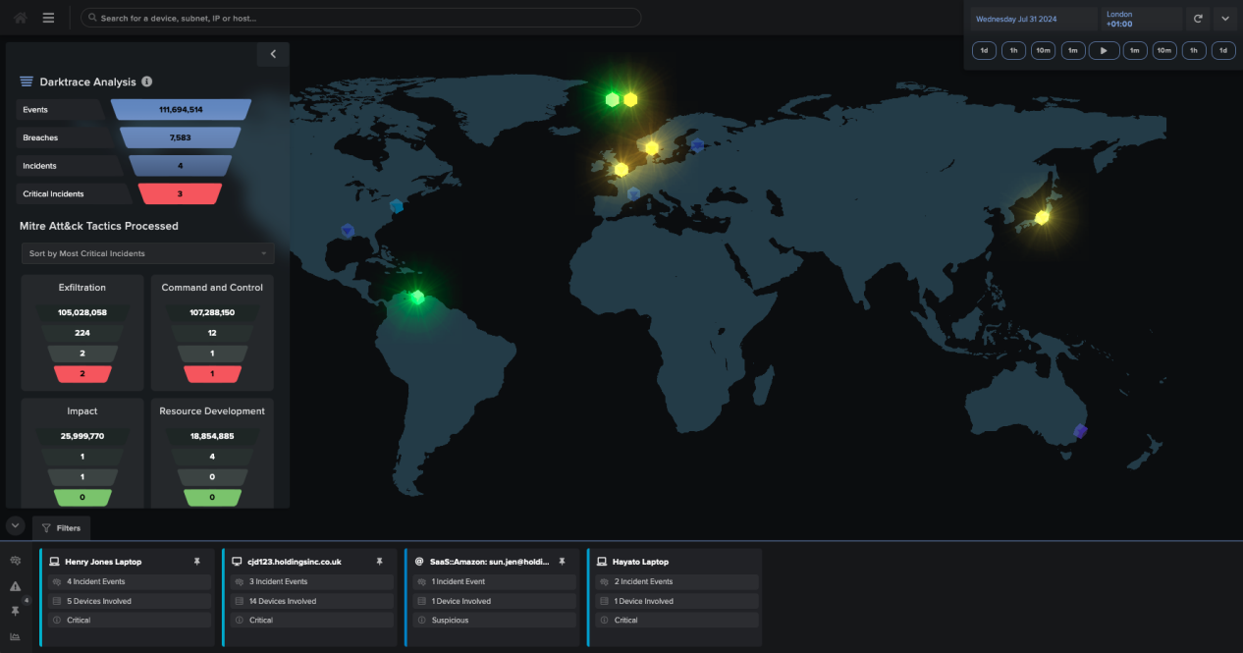

Vectra AI Platform
The Vectra AI Platform is a leading Threat Detection, Investigation, and Response (TDIR) solution designed to secure hybrid and multi-cloud enterprises (Vectra AI, 2025b). Originally known as Vectra Cognito, the platform has evolved from a dedicated Network Detection and Response (NDR) tool into a unified security ecosystem that integrates signals across four primary attack surfaces: public cloud, SaaS, identity, and data center networks (Crayon, 2026; Vectra AI, 2021). Its core methodology focuses on detecting attacker behaviors—specifically Tactics, Techniques, and Procedures (TTPs)—rather than relying on static signatures or simple anomaly detection (Vectra AI, 2024b).

Key Capabilities and Core Features

Attack Signal Intelligence™: This patented technology automates threat detection and triage by using a combination of supervised and unsupervised machine learning (Vectra AI, 2023). It establishes a dynamic "normal" baseline for every device and user, allowing it to distinguish between benign anomalies and high-fidelity attack behaviors, which reportedly reduces alert noise by 80% (Help Net Security, 2023; Skywork, 2025).

Unified Observability: The platform provides a single-pane-of-glass view for monitoring millions of IPs and billions of sessions across disparate environments, including AWS, Microsoft 365, and Active Directory (Gartner, 2026; PR Newswire, 2026).

Threat Certainty Index™: Vectra automatically consolidates detections and assigns scores to identify which hosts pose the greatest risk in real-time. This allows Security Operations Center (SOC) teams to prioritize the most urgent threats, often reducing investigation times from days to minutes (Vectra AI, 2025a; Stinet, 2020).

Integrated Response: The platform supports both native and orchestrated response actions. It can manually or automatically isolate compromised endpoints, disable accounts, or trigger third-party Security Orchestration, Automation, and Response (SOAR) playbooks through over 40 ecosystem integrations (Vectra AI, 2025b).

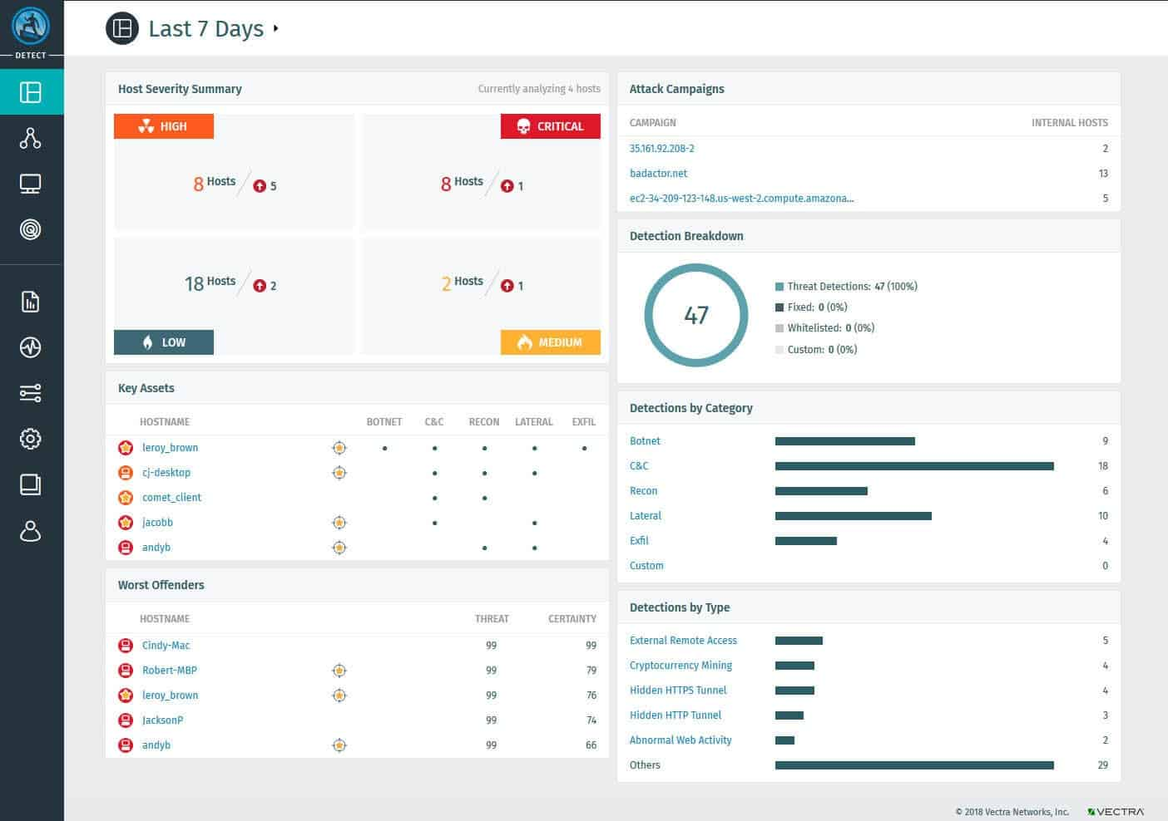

BluVector (DataBee® BluVector)
BluVector is an AI-driven Network Detection and Response (NDR) platform that specializes in the real-time identification of sophisticated, fileless, and zero-day malware (Vectra AI, 2025b). Originally developed within the US defense and intelligence sectors, BluVector was acquired by Comcast in 2019 to bolster its cybersecurity portfolio (Comcast, 2019). Recently, the technology was integrated into DataBee®, Comcast’s security data fabric platform, to provide an on-premise solution that leverages multi-patented machine learning to disrupt attacks at line speed (Business Wire, 2025).

Key Capabilities and Core Features

Patented Machine Learning Engine (MLE): BluVector’s core differentiator is its patented supervised machine learning engine (U.S. Patent 9,665,713), which has been trained on over 55 million file samples (DataBee, 2025b). This allows the system to detect polymorphic and zero-day threats without relying on traditional signatures (Carahsoft, 2024).

Speculative Code Execution: To counter fileless malware—which resides only in memory—BluVector utilizes a speculative code execution engine to analyze the intent of code as it traverses the network, rather than waiting for it to be written to a disk (Miercom, 2019).

In-Situ Retraining: A unique feature (U.S. Patent 10,121,108) that enables the platform to perform localized, on-premise retraining of its AI models (DataBee, 2025a). This ensures the system adapts to an organization's specific network environment while maintaining data privacy, as no data needs to be sent back to the vendor for model updates (NCSI, 2020).

High-Speed Visibility and Open Architecture: Designed for massive data throughput, the platform can inspect packets at speeds exceeding 10 Gbps (Business Wire, 2025). It integrates modular open-source tools like Zeek and Suricata with its proprietary engines, providing security teams with granular logging and forensic evidence for threat hunting (Garland Technology, 2025).
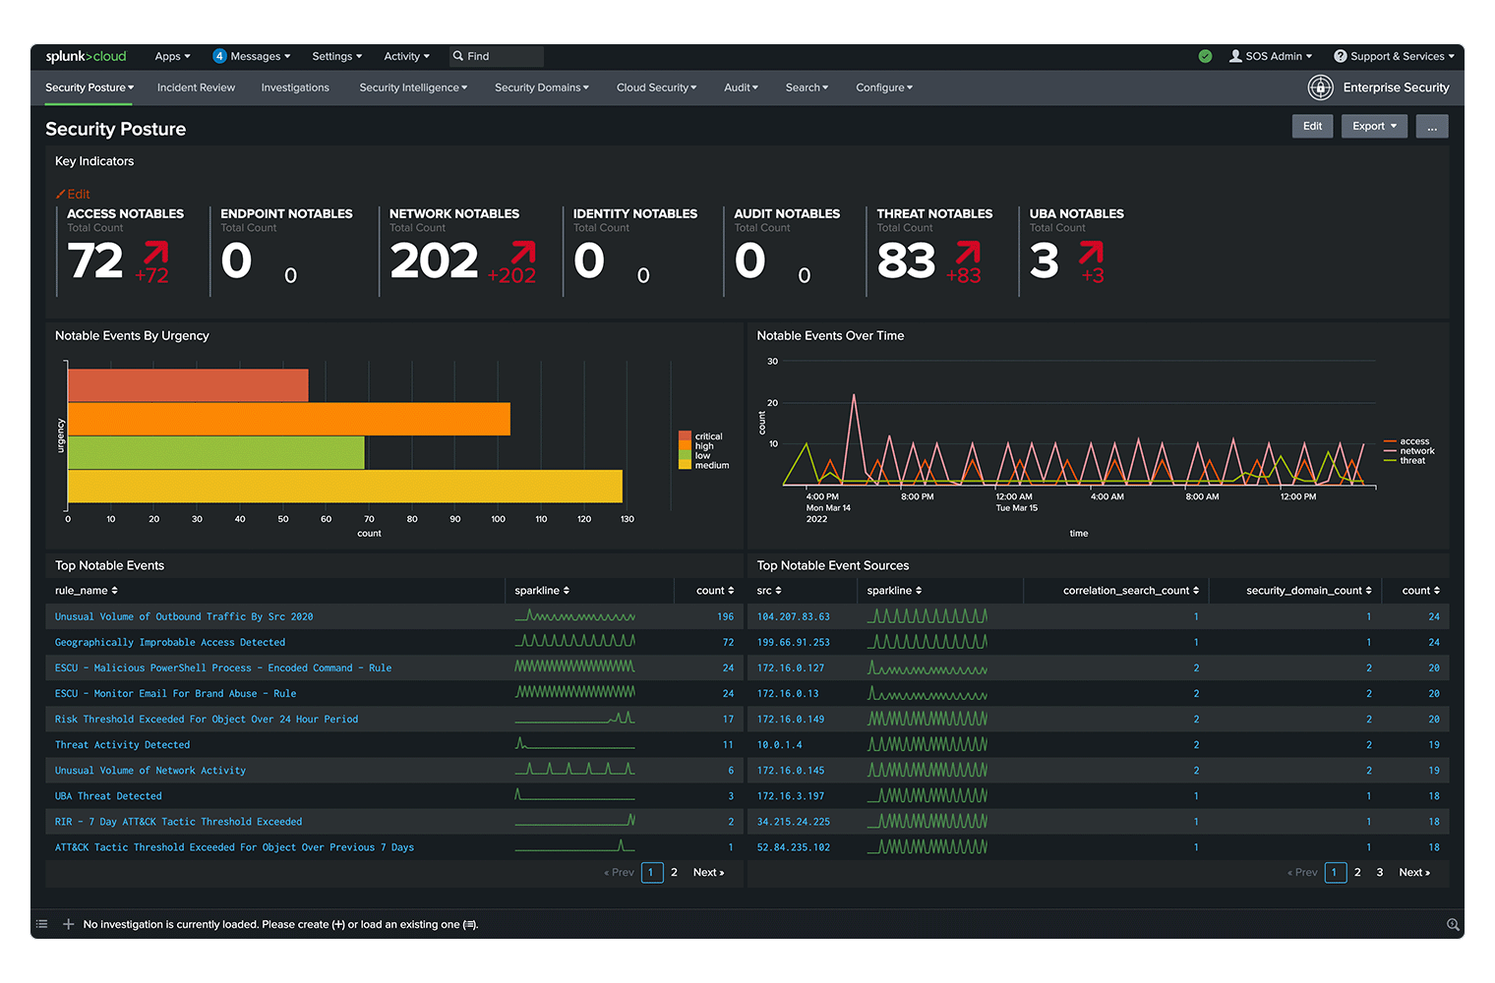

Trellix (formerly McAfee + FireEye)
Trellix is a privately held cybersecurity firm established in 2022 following the merger of McAfee Enterprise and FireEye Products by the Symphony Technology Group (STG) (Wikipedia, 2026). The organization positions itself as a leader in Extended Detection and Response (XDR), integrating the legacy network, endpoint, and cloud security portfolios of its predecessors into a unified "living security" ecosystem (Dark Reading, 2022). While the Mandiant incident response unit and Skyhigh Security (McAfee's SSE business) were separated during the divestiture, Trellix retained the core threat detection engines and the Helix orchestration platform (Computing UK, 2022; Orca Tech, 2024).

Key Capabilities and Core Features

Integrated XDR Platform: Trellix utilizes an open and native XDR architecture that ingests telemetry from over 600 native and third-party security technologies (Gartner, 2025). This integration allows for cross-vector correlation, enabling Security Operations Center (SOC) teams to visualize the entire attack chain from a single interface (Trellix, 2025a).

Network Detection and Response (NDR): Evolving from the legacy FireEye Network Security (NX), Trellix NDR provides deep visibility into lateral movement and encrypted traffic without requiring decryption (Trellix, 2025d). It employs Attack Signal Intelligence and machine learning to establish environment-specific baselines, identifying subtle behavioral anomalies such as beaconing or ICMP tunneling (Business Wire, 2025).

Helix Orchestration and Hyper-automation: The Trellix Helix platform serves as the central "brain," utilizing AI-powered analytics to automate threat triaging and guided investigations (Trellix, 2025c). Recent updates include Hyperautomation, a no-code, drag-and-drop workflow builder that allows analysts to automate response actions like system isolation or account disabling across hybrid environments (Help Net Security, 2025).

Endpoint Security (HX and ENS): Trellix combines McAfee’s Endpoint Security (ENS) with FireEye’s Endpoint Security (HX) to provide a multi-layered defense-in-depth strategy (Trellix, 2025e). This includes signature-based prevention, machine learning for zero-day threats, and Endpoint Detection and Response (EDR) with integrated forensics for remote incident containment (UCI OIT, 2025; Trellix, 2023)

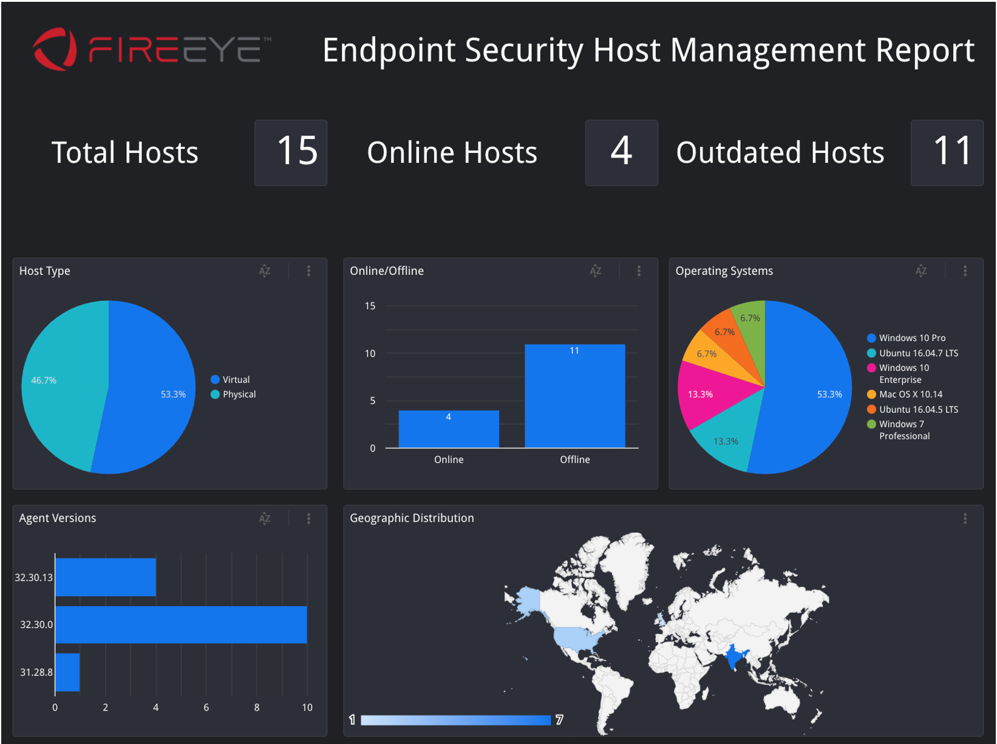

2.3 RESEARCH GAP

From the literature reviewed, several critical gaps have been identified:

Gap Area | Description | Significance | Proposed Solution
Detection vs. Analysis | Most systems detect attacks but do not perform root-cause breach analysis. | Limits post-incident understanding. | Integrate forensic tracing and causal modelling.
Model Interpretability | Deep learning systems often act as black boxes. | Reduces user trust and regulatory compliance. | Incorporate XAI (SHAP, LIME) for transparency.
Scalability | High data velocity in enterprise networks challenges ML scalability. | Affects real-time detection. | Develop distributed, modular architectures.
Adversarial Evasion | Attackers manipulate input to fool ML models. | Undermines security reliability. | Apply adversarial training and ensemble methods.

This project specifically targets these gaps by creating a scalable, explainable, and adaptive intrusion detection and breach analysis framework.

2.4 CONCLUSION

The literature review demonstrates that AI and ML technologies have profoundly advanced network intrusion detection but that significant challenges persist in interpretability, scalability, and root-cause analysis. By adopting explainable and adaptive AI methods, cybersecurity systems can evolve from reactive to proactive defence tools. The next chapter outlines the methodological framework guiding this study, detailing how Design Science Research and Agile development principles will be combined to design, implement, and evaluate the proposed system.

CHAPTER 3: METHODOLOGY

3.0 INTRODUCTION

This chapter outlines the methodological framework used in the development of the AI-powered Intrusion Detection and Breach Analysis System. The methodology integrates both Design Science Research Methodology (DSRM) and Agile development principles, ensuring a structured yet flexible approach that supports iterative refinement.

The Design Science approach provides the foundation for building and evaluating the research artefact, while the Agile methodology ensures adaptability to evolving requirements and emerging findings during system development. Together, these approaches support a comprehensive research process that moves from problem identification to artefact evaluation, ensuring both academic rigour and practical relevance.

  - RESEARCH METHODOLOGY APPROACH

    - DESIGN SCIENCE RESEARCH METHODOLOGY (DSRM)

The Design Science Research Methodology (DSRM) focuses on the creation and evaluation of artefacts that address identified real-world problems (Peffers et al., 2007). It is particularly suited for information systems and cybersecurity research, where both theoretical contribution and practical application are required.
The DSRM framework consists of six sequential and iterative phases:

Problem Identification and Motivation
The increasing sophistication of cyberattacks has exposed the inadequacy of existing intrusion detection systems, which often detect anomalies without explaining their root causes or tracing their propagation paths. This motivates the need for an intelligent system capable of providing contextual and interpretable analyses of detected breaches (Ahmad et al., 2021).

Define the Objectives of the Solution
The primary objective is to design an AI-driven system capable of detecting, classifying, and analysing cyberattacks while providing interpretable forensic outputs. This includes:
Enhancing detection accuracy through ML and Deep Learning algorithms.
Integrating Explainable AI (XAI) techniques (e.g., SHAP, LIME) to ensure interpretability.
Tracing attack paths and identifying exploited vulnerabilities.
Producing actionable forensic reports for mitigation.

Design and Development
The artefact will be developed iteratively using ML and XAI frameworks. The process involves:

Data Collection: Using benchmark datasets such as UNSW-NB15, CICIDS2017, and KDD Cup 1999, as well as simulated traffic captured via Wireshark and TCP-dump.
Data Pre-processing: Cleaning, feature extraction, normalisation, and balancing using methods like SMOTE to handle class imbalance.

Model Development: Implementing ML algorithms (Random Forest, SVM, CNN, RNN, Autoencoders) and applying hyperparameter tuning via Grid and Random Search.

Explainability Integration: Using XAI tools (SHAP, LIME) to provide interpretable visual outputs for analysts.

Demonstration
The developed prototype will be deployed in a simulated network environment that mimics real-world traffic. It will detect, classify, and analyse various types of cyberattacks in near real-time. Integration with Security Information and Event Management (SIEM) systems will also be explored to assess operational compatibility.

Evaluation
The artefact will be evaluated both quantitatively and qualitatively:

Quantitative Evaluation: Measuring performance using metrics such as Accuracy, Precision, Recall, F1-score, and ROC-AUC.

Qualitative Evaluation: Assessing interpretability and usability of XAI explanations through expert feedback.

Comparative benchmarking will be conducted against established intrusion detection models to assess improvements.

Communication
Findings—including system design, evaluation results, and lessons learned—will be disseminated through the final dissertation and potential academic publications. The communication phase ensures that the research contributes both academically and practically to the field of AI-driven cybersecurity.

The DSRM approach ensures that each phase informs the next, creating a feedback loop that refines the artefact until it meets both technical and research objectives.

    - JUSTIFICATION OF RESEARCH METHODOLOGY

The DSRM was chosen because it aligns with the study’s aim of developing a functional artefact that addresses a clearly defined cybersecurity problem. It facilitates a rigorous balance between theory and practice—producing not only a working solution but also new insights into how AI and XAI can improve interpretability in intrusion detection.

This methodology is appropriate because:

- It allows iterative refinement of the AI model and system architecture.
- It ensures systematic evaluation using both qualitative and quantitative measures.
- It emphasises the practical contribution of the artefact, ensuring its relevance in real-world applications.

Additionally, by embedding Explainable AI (XAI) principles within the DSRM process, the study enhances transparency, ethical compliance, and trustworthiness in AI-driven decision-making—key requirements in modern cybersecurity practice (Islam et al., 2023).

  - ETHICAL CONSIDERATIONS

The development of an AI-powered Intrusion Detection and Breach Analysis System requires careful adherence to ethical standards to safeguard data privacy, ensure responsible use of Artificial Intelligence, and maintain the integrity of the research process. As the project involves the handling of network traffic and the application of machine learning models to security-related data, ethical considerations play a central role in the methodological framework of the study.
    - Data Privacy and Confidentiality
All data used in this research will be sourced from publicly available and fully anonymised cybersecurity datasets, specifically UNSW-NB15, CICIDS2017, and KDD Cup 1999. These datasets contain no personally identifiable information (PII), ensuring compliance with privacy requirements.
For simulated attack traffic generated during experimentation, data capture will occur within secure and isolated virtual environments. No real-world user data, corporate logs, or private network information will be accessed or stored. All collected data will be anonymised, encrypted where appropriate, and accessible only to authorised members of the research team.

3.2.2 Legal and Regulatory Compliance
The study adheres to the General Data Protection Regulation (GDPR) and institutional data governance policies outlined by the National University of Science and Technology. No external organisational networks or systems will be monitored or tested without explicit consent. The research will follow the ethical review procedures required by the university, ensuring full compliance with academic and legal requirements for conducting cybersecurity research.

3.2.3 Responsible and Transparent Use of AI
As Artificial Intelligence models may introduce bias, opacity, or misinterpretation, the project integrates Explainable AI (XAI) methods—namely SHAP and LIME—to promote transparency and accountability. These methods will ensure that the system’s predictions can be clearly interpreted by cybersecurity analysts, reducing the risks associated with “black-box” decision-making.
Additionally, model fairness will be evaluated by monitoring false positives and false negatives across multiple attack classes. This prevents unintentional prioritisation of certain threat types or suppression of others, thereby supporting balanced and responsible AI performance.

3.2.4 Security, Safety, and Misuse Prevention
All experiments involving cyberattacks—such as DoS, brute force, and data exfiltration simulations—will be conducted within fully isolated virtual machines or sandbox environments. This ensures that attack simulations do not affect external networks, systems, or users.
The artefact developed in this study is intended strictly for defensive purposes in cybersecurity. It will not be used for penetration testing without authorisation, exploitation of vulnerabilities, or any offensive cyber operations. Documentation accompanying the system will explicitly state its ethical scope and intended lawful use.
3.2.5 Research Transparency and Integrity
The research process will be documented thoroughly to ensure transparency, replicability, and academic integrity. This includes maintaining clear records of data preprocessing steps, model configurations, evaluation metrics, and system design iterations. Any limitations or biases identified during model training or testing will be openly disclosed in the final dissertation.
Peer feedback and supervisor oversight will be incorporated at multiple stages to ensure objectivity and methodological soundness.

Ethical Risk | Description | Mitigation Strategy
Exposure of sensitive or personal data | Risk of inadvertently accessing or processing identifiable information. | Use only anonymised, publicly available datasets; generate synthetic or simulated data; restrict data access.
Unintended misuse of the developed system | System could be repurposed for offensive hacking or reconnaissance. | System documentation limits use to defensive research; simulations run only on isolated testbeds.
Bias or opacity in AI model decisions | Black-box models may produce unexplained or unfair results. | Integrate XAI (SHAP, LIME); evaluate fairness; provide interpretability outputs for all predictions.
Regulatory non-compliance | Potential breach of GDPR or institutional policies. | Follow GDPR principles; use anonymised data; obtain institutional ethical clearance; review data governance protocols.
Security risks during attack simulation | Attack traffic could escape the test environment. | Use sandboxed, offline virtual networks; implement strict firewall rules; document responsible procedures.
Lack of transparency in research process | Poor documentation may hinder reproducibility and accountability. | Maintain detailed logs, version control, and methodological documentation throughout the project.

  - SOFTWARE DEVELOPMENT METHODOLOGY

    - AGILE DEVELOPMENT (KANBAN FRAMEWORK)

The software development process follows the Agile philosophy, specifically using the Kanban methodology. Kanban provides a flexible, visual, and incremental approach that supports continuous improvement and adaptability throughout the project lifecycle (Hamed et al., 2024).

Key characteristics of the Kanban methodology applied in this research include:

Visual Workflow Management: All tasks are represented on a Kanban board with stages such as To Do, In Progress, Testing, and Completed. This allows for clear visibility and tracking of progress.

Incremental Development: The system is developed in iterative sprints, enabling frequent evaluation and integration of new requirements.

Continuous Feedback: Regular assessment of system performance and stakeholder input supports refinement of features and model behaviour.

Flexibility: The Kanban approach allows adjustments to be made dynamically based on challenges such as model performance variations or new attack simulations.

Kanban Workflow Implementation for the Project:

Planning: Define system requirements and data sources.

Model Development: Build and train ML algorithms.

Integration: Incorporate XAI visualisation modules.

Testing: Evaluate detection accuracy, interpretability, and system response time.

Iteration: Implement feedback and improve artefact performance.

This iterative framework aligns with the DSRM’s focus on continuous refinement, ensuring that each development stage contributes meaningfully to solving the identified research problem.
  - CONCLUSION

This chapter has detailed the methodological framework underpinning the study, explaining how the Design Science Research Methodology and Agile Kanban approach will guide the development of the AI-powered intrusion detection and breach analysis system. The combination of DSRM and Agile ensures a balance between academic rigour and practical adaptability.
By systematically designing, implementing, and evaluating the artefact, this research seeks to produce a robust, interpretable, and scalable solution that advances the field of AI-driven cybersecurity. The next chapter will present the System Analysis and Design, including architectural diagrams and component specifications for the proposed system.

CHAPTER 4

SYSTEM ANALYSIS AND DESIGN

4.1 Introduction
This chapter presents the system analysis and design of the AI-Powered Network Intrusion Detection and Breach Analysis System developed for this research. The chapter describes the architectural framework of the system, the key modules that constitute the intrusion detection platform, the technologies used in its development, as well as the implementation environment and user interface design. The goal of this chapter is to demonstrate how the proposed system integrates network monitoring, machine learning-based intrusion detection, and breach analysis capabilities into a unified architecture capable of identifying and analysing malicious network activities in real time.

Modern network infrastructures are increasingly exposed to sophisticated cyber threats, requiring advanced monitoring systems capable of analysing network traffic and detecting anomalies automatically. Intrusion Detection Systems (IDS) play a critical role in identifying unauthorized or malicious activities within networks (Scarfone & Mell, 2007). The system developed in this study integrates artificial intelligence techniques with real-time packet inspection to enhance the accuracy and responsiveness of intrusion detection mechanisms.

4.2 System Architecture
The proposed AI-powered Network Intrusion Detection System (IDS) follows a modern client–server architecture designed to separate the user interface from the computationally intensive network monitoring and analysis processes.

The architecture consists of two primary layers:

Frontend Layer (Client Interface)
Backend Layer (Detection and Analysis Engine)

The frontend component is implemented using Next.js, a modern React-based framework that provides dynamic user interfaces and real-time data visualization. The frontend communicates with the backend through RESTful APIs to retrieve alert information, system statistics, and breach analysis results.

The backend is implemented using FastAPI, a high-performance Python framework designed for building scalable APIs. The backend is responsible for packet capture, feature extraction, intrusion detection processing, and breach analysis using machine learning algorithms.

To provide a clear understanding of how the proposed intrusion detection system operates, it is necessary to examine the overall architecture of the system. The architecture defines how the various components of the system interact in order to capture network traffic, analyse potential threats, and present security alerts to administrators. The system follows a modular architecture in which network monitoring, threat detection, breach analysis, and user interface components operate together to deliver real-time intrusion detection capabilities. The high-level structure of the system architecture is illustrated in Figure 4.1.

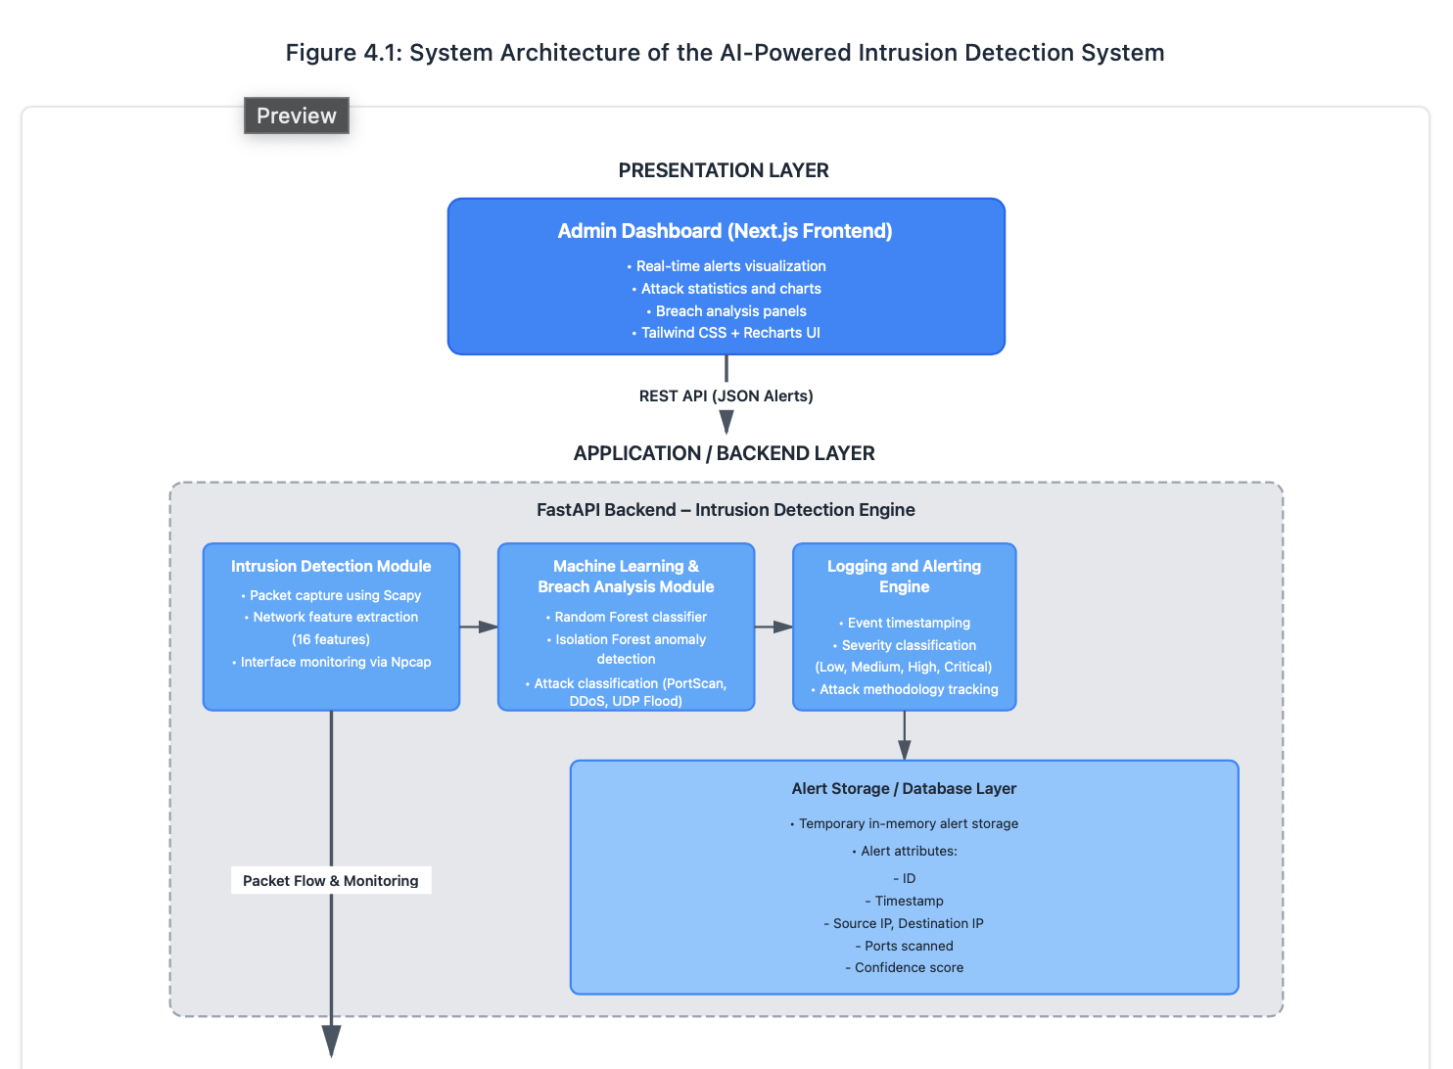

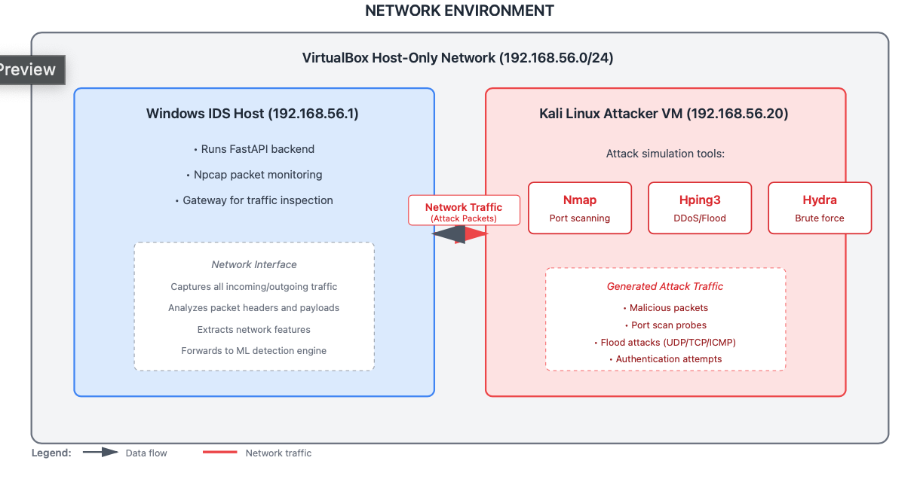
The system follows a client–server architecture where the intrusion detection engine operates within the FastAPI backend while the administrative dashboard provides visualization and monitoring capabilities through a Next.js frontend.

Captured network packets are processed by the Intrusion Detection Module, which extracts relevant network traffic features. These features are analysed by the Machine Learning and Breach Analysis module to determine whether the traffic represents malicious behaviour.

Detected threats are logged by the Logging and Alerting module, which records information such as attack type, severity, source IP address, and affected services. Alerts are then exposed through a REST API and displayed in real time on the administrative dashboard.

To overcome hardware restrictions associated with Wi-Fi promiscuous mode monitoring on Windows systems, the system operates within a controlled VirtualBox Host-Only Network environment using the 192.168.56.0/24 subnet. Within this network topology:

The Windows host machine acts as the IDS monitoring node and network gateway with IP address 192.168.56.1.

A Kali Linux virtual machine, configured with IP address 192.168.56.20, functions as the simulated attacker node used to generate controlled attack traffic for system testing.

This configuration enables the IDS to capture and analyse network packets flowing between nodes within the isolated network environment while maintaining complete visibility of packet flows.

To evaluate the performance of the proposed intrusion detection system in a controlled environment, a virtual network testbed was developed. The testing environment simulates a realistic network scenario in which malicious traffic is generated from an attacker machine and monitored by the intrusion detection system. This controlled setup allows the system to be tested against different attack techniques without exposing external networks to potential risks. The structure of the experimental network environment used during system testing is illustrated in Figure 4.2.

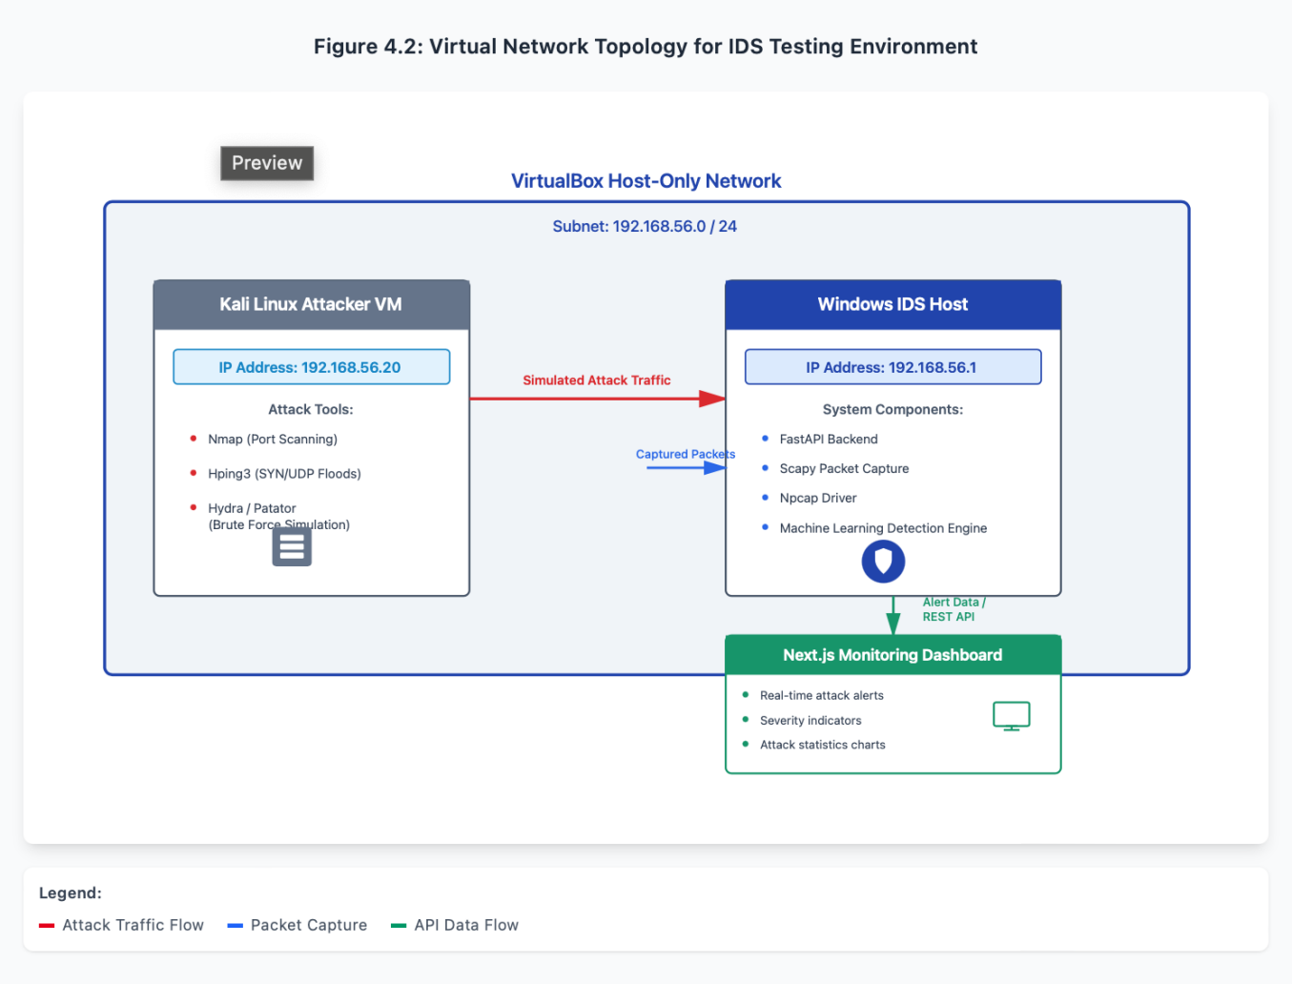

Figure 4.2 illustrates the virtual network configuration used during system testing. The experimental environment is implemented using a VirtualBox host-only network configured within the 192.168.56.0/24 subnet. Within this network, a Kali Linux virtual machine functions as the attacker system responsible for generating simulated cyber attacks using tools such as Nmap and Hping3. The Windows host machine operates as the intrusion detection system and runs the packet monitoring engine, machine learning detection model, and administrative dashboard. All network traffic generated by the attacker is transmitted through this isolated network environment, enabling the IDS to capture and analyse packets in real time while maintaining a safe and reproducible testing environment.

The system architecture therefore ensures:

Real-time packet capture and monitoring
Efficient backend processing of network traffic
Interactive visualization of security alerts through the frontend dashboard

The decoupled design also allows the frontend and backend to be developed and scaled independently, improving system maintainability and performance.

4.4 Intrusion Detection Data Processing Pipeline
The effectiveness of the proposed intrusion detection system depends on its ability to capture network packets, extract relevant traffic features, analyse the data using intelligent detection mechanisms, and generate actionable security alerts. To achieve this, the system implements a structured data processing pipeline that transforms raw network traffic into classified security events. The pipeline ensures that packets captured from the monitored network interface pass through several processing stages including packet capture, feature extraction, threat detection, breach analysis, and alert generation. Each stage plays a specific role in transforming low-level packet data into meaningful intrusion detection insights.

The data processing pipeline begins with the acquisition of raw network traffic from the monitored interface. Incoming packets are captured in real time and forwarded to the feature extraction module, where important attributes of the network traffic are identified. These extracted features are then analysed by the detection engine, which combines rule-based detection mechanisms with machine learning models to classify potential threats. Once suspicious behaviour is identified, the breach analysis module evaluates the severity and characteristics of the attack and generates a structured security alert that is recorded by the logging subsystem and presented to the administrative dashboard.
The pipeline architecture ensures that the intrusion detection process remains efficient and scalable by separating each processing task into clearly defined stages. This modular approach improves maintainability and allows the system to integrate additional detection techniques or data analysis components in future versions.

Intrusion Detection Data Processing Pipeline
In order to understand how the proposed intrusion detection system processes network traffic, it is important to examine the internal data processing workflow used to transform raw packet data into meaningful security alerts. The system processes captured packets through a series of structured stages that include packet capture, feature extraction, threat detection, breach analysis, and alert generation.
This multi-stage pipeline ensures that network traffic is systematically analysed and classified before security alerts are generated.

Figure 4.3: Intrusion Detection Data Processing Pipeline
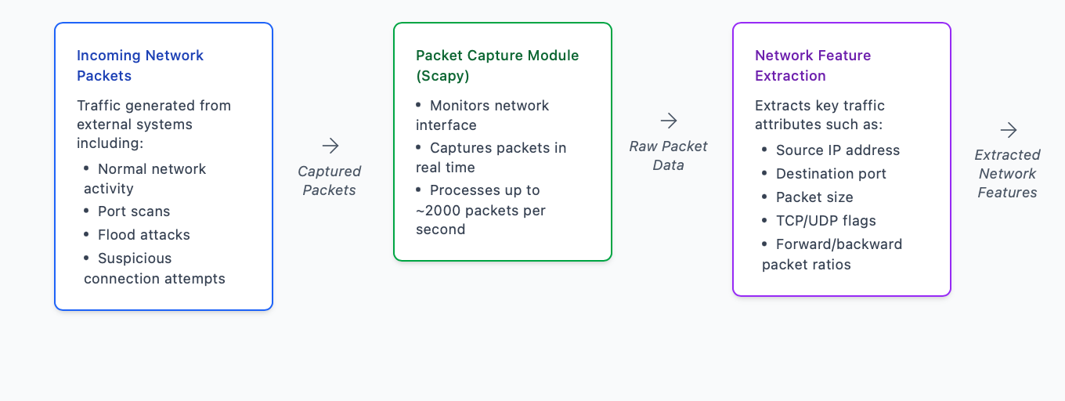
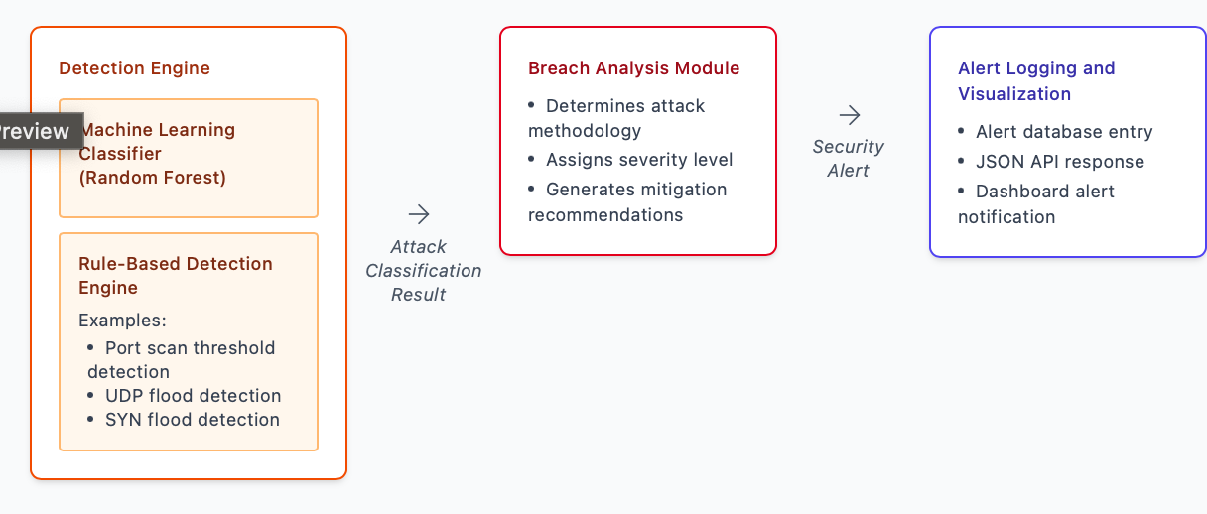
The intrusion detection pipeline illustrated in Figure 4.3 begins with the network traffic capture stage, where packets are collected from the monitored network interface using the Scapy packet manipulation library. This module operates in promiscuous mode through the Npcap driver, enabling the system to observe all network packets transmitted across the monitored network segment. The captured packets represent both legitimate network communication and potentially malicious traffic generated during attack simulations.

Following packet capture, the feature extraction module processes each packet and derives a set of relevant network flow attributes. These attributes include information such as source and destination IP addresses, destination ports, packet sizes, transport protocol types, and TCP flag indicators. Additional metrics such as packet rate and forward-to-backward packet ratios are also calculated to provide meaningful indicators of abnormal network behaviour. These extracted features serve as the input data used by the detection mechanisms.

The extracted traffic features are then passed to the detection engine, which performs threat classification using a dual-layer detection strategy. The first layer consists of a rule-based detection mechanism designed to identify well-known network attack patterns based on predefined thresholds and traffic behaviour indicators. For example, a large number of connection attempts to multiple ports within a short period may indicate a port scanning attack, while an unusually high packet transmission rate may suggest a denial-of-service or distributed denial-of-service attack.

The second detection layer incorporates machine learning analysis using a Random Forest classifier trained on the CIC-IDS2017 dataset. The classifier is capable of identifying complex traffic patterns associated with various cyber attacks by comparing extracted network features with patterns learned during the training phase. In addition, anomaly detection techniques such as Isolation Forest algorithms can be applied to detect unusual traffic behaviour that deviates significantly from normal network activity.

Once malicious traffic is identified, the system forwards the detection results to the breach analysis module. This module evaluates the characteristics of the detected attack and generates contextual information describing the intrusion event. The analysis includes identifying the attack methodology, determining the severity level of the threat, and assessing the potential impact on the monitored system. Based on this evaluation, the module may also produce mitigation recommendations to assist administrators in responding to the detected threat.
Finally, the processed security event is recorded by the alert logging and visualization subsystem. The alert is stored as a structured record containing relevant information such as the detection timestamp, attack classification, source IP address, destination IP address, affected network ports, and detection confidence score. These alerts are exposed through the system’s REST API and displayed on the administrative dashboard, allowing system administrators to monitor network security events in real time.

Through this structured processing pipeline, the system is able to transform raw packet-level network data into meaningful intrusion detection alerts. The modular design of the pipeline not only improves detection accuracy but also allows for future enhancements such as advanced machine learning models, improved feature extraction techniques, and integration with enterprise security monitoring platforms.

4.3 System Modules and Components
The proposed intrusion detection system is composed of several functional modules that work together to capture network traffic, analyse potential attacks, and generate security alerts.

4.3.1 Intrusion Detection Module
The intrusion detection module serves as the core packet analysis engine responsible for monitoring incoming network traffic. The module is implemented in Python and uses the Scapy packet manipulation library to capture and inspect network packets from the selected network interface.

The module listens to the Windows packet capture interface:\Device\NPF_{GUID}, which is provided by the Npcap packet capture driver. This interface allows the system to intercept network packets in real time.

Captured packets are processed continuously, and essential network features are extracted from each packet flow. A total of sixteen network traffic features are derived from packet data, including attributes such as:

Source and destination IP addresses
Destination ports
Packet sizes
TCP flag ratios
Forward and backward packet counts
Packet rate statistic.
These extracted features provide the input data required by the machine learning detection engine.

4.3.2 Machine Learning and Breach Analysis Module
The Machine Learning and Breach Analysis Module is responsible for classifying network activities as either normal traffic or malicious behaviour. The module implements machine learning models using the scikit-learn library and is trained using the CIC-IDS2017 dataset, which contains a comprehensive collection of modern network attack scenarios.

The primary classification model used within the system is a Random Forest classifier, which demonstrated high predictive accuracy during model evaluation.

The model achieved a validation accuracy of 99.86% when tested against the CIC-IDS2017 dataset, covering multiple attack types including:

Distributed Denial of Service (DDoS)
Port scanning
UDP flood attacks
Brute-force login attempts
Suspicious traffic patterns

To complement the supervised learning model, the system also incorporates Isolation Forest anomaly detection, which identifies abnormal traffic patterns that deviate from typical network behaviour.

In situations where machine learning predictions may not be fully applicable due to feature mapping constraints, the system employs rule-based detection algorithms to identify common attack signatures. Examples of rule-based detection include:

Identifying port scanning activities when more than 50 unique ports are targeted.
Detecting Distributed Denial of Service (DDoS) attacks when packet rates exceed 1000 packets per second.
Recognizing UDP flood attacks based on abnormal UDP traffic ratios.

Once an attack is detected, the breach analysis engine generates forensic insights including:

Attack methodology
Vulnerability exploitation techniques
Potential impact on the system
Recommended mitigation strategies

4.3.3 Machine Learning Detection Workflow
Machine learning techniques play an important role in improving the accuracy and adaptability of modern intrusion detection systems. Unlike traditional signature-based approaches, machine learning models can identify patterns and anomalies in network traffic that may indicate previously unknown attacks. In the proposed system, a Random Forest classifier was trained using a labelled intrusion detection dataset to enable automated classification of malicious network behaviour. The workflow used to train the machine learning model and apply it to real-time traffic analysis is illustrated in Figure 4.4.

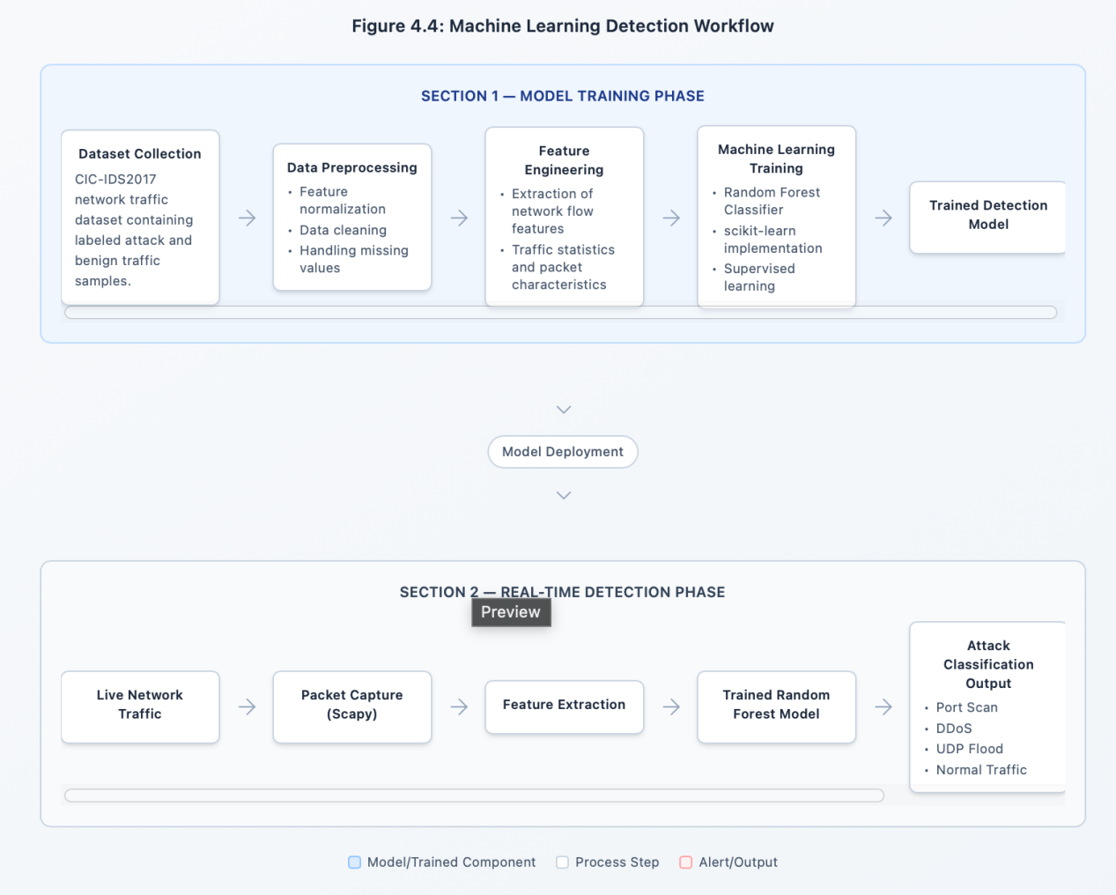

Figure 4.4 demonstrates the two primary phases involved in the machine learning detection process: the model training phase and the real-time detection phase. During the training phase, the system uses the CIC-IDS2017 dataset to train the Random Forest classifier after performing preprocessing and feature engineering on the network traffic data. The trained model learns patterns associated with both normal and malicious traffic behaviour. During the real-time detection phase, network packets captured by the intrusion detection engine are converted into feature vectors that are analysed by the trained model. Based on the extracted features, the model classifies the traffic as either benign or malicious and forwards the classification results to the breach analysis module for alert generation.

4.3.3 Logging and Alerting Module
The logging and alerting module is responsible for maintaining detailed records of detected intrusion events. This module records essential metadata associated with each detected attack, including:

Timestamp of detection
Attack type
Severity classification
Confidence score
Source IP address
Destination IP address
Targeted ports

These alerts are made accessible to the frontend dashboard through the FastAPI REST interface. The real-time alerting mechanism ensures that network administrators are immediately notified when malicious activities occur.
Severity levels are categorised as:

Low
Medium
High
Critical

This classification allows administrators to prioritise responses based on the potential impact of the detected threat.

4.3.4 Database Module
The database module manages the storage of intrusion detection logs and breach analysis reports. During the prototype development phase, the system utilizes in-memory data structures for rapid event logging and processing.
However, the system is designed to support integration with persistent databases for long-term storage of security events.
The conceptual database schema includes an Alert table with the following attributes:

Field | Description
ID | Unique identifier for each alert
Timestamp | Time of detection
Type | Attack classification
Severity | Risk level
Confidence | Machine learning confidence score
Source IP | Origin of attack
Destination IP | Target system
Ports scanned | Targeted ports
Attack methodology | Detailed forensic description
Vulnerabilities | Identified weaknesses exploited
Impact Assessment | Estimated system impact

Future implementations may integrate relational databases such as PostgreSQL or MongoDB to support persistent storage and large-scale intrusion log analysis.

4.3.5 Administrative Dashboard Interface
The administrative interface provides a centralized monitoring platform that allows system administrators to visualize security alerts and network activity.
The interface is built using Next.js, Tailwind CSS, and Recharts, enabling interactive dashboards and graphical representations of network attack patterns.

Key dashboard features include:

Real-time intrusion alerts
Packet capture control functions
Attack severity visualisation
Traffic statistics and graphs
Attack timeline analysis

The dashboard automatically refreshes every five seconds, ensuring administrators receive timely updates regarding system activity.

4.4 Technologies Used
The development of the IDS relied on a combination of modern programming languages, frameworks, and network monitoring tools.

Programming Languages
The backend system was implemented using Python 3.11, while the frontend user interface was developed using JavaScript and TypeScript running on Node.js 20.x.

Frameworks
Two major frameworks were used in system development:
FastAPI – for building high-performance REST APIs
Next.js 16 (React 19) – for the interactive web-based dashboard

Machine Learning Libraries
Machine learning capabilities were implemented using several Python libraries including:

scikit-learn for classification models
NumPy for numerical computations
Pandas for dataset manipulation
Joblib for model serialization and loading
Network Monitoring Tools

Several specialized networking tools were used during development and testing:

Scapy – packet capture and network analysis
Npcap – packet capture driver for Windows
VirtualBox 7.x – virtual machine management
Nmap – port scanning simulation
Hping3 – network attack generation
Hydra – brute force attack simulation

These tools enabled the system to simulate real-world attack scenarios and evaluate the effectiveness of the IDS.

4.5 System Implementation
The system was implemented on a Windows host operating system, primarily to leverage the Npcap packet sniffing driver, which provides reliable packet capture capabilities.

The backend operates using a multi-stage processing pipeline consisting of the following steps:

Packet Capture
Network packets are captured using the Scapy library from the VirtualBox host-only network interface. The system continuously captures packets in batches of approximately 100 to 2000 packets per second, depending on network activity levels.

Feature Extraction
Once packets are captured, relevant flow-based features are extracted from the packet headers and payload data. These features are then formatted into a structure compatible with the machine learning classification model.

Detection Logic
The detection engine applies a dual-layer detection strategy combining machine learning predictions and rule-based analysis.

The machine learning classifier processes extracted features and predicts the probability of malicious behaviour. If the prediction indicates suspicious activity, the rule-based engine performs additional verification using predefined detection thresholds.

For example:

Port scanning is detected when an attacker targets more than 50 unique destination ports.

DDoS attacks are flagged when packet rates exceed 1000 packets per second.
This hybrid detection strategy improves the reliability of the IDS and reduces false positives.

4.5 System Compomnent Interaction
The proposed intrusion detection system is composed of several interconnected modules that work together to monitor network traffic and generate security alerts. Each module performs a specialized function within the system, including packet capture, threat detection, breach analysis, and alert logging. Understanding how these components interact is essential for analysing the overall behaviour of the system. The relationships and communication flow between the different system modules are illustrated in Figure 4.5.
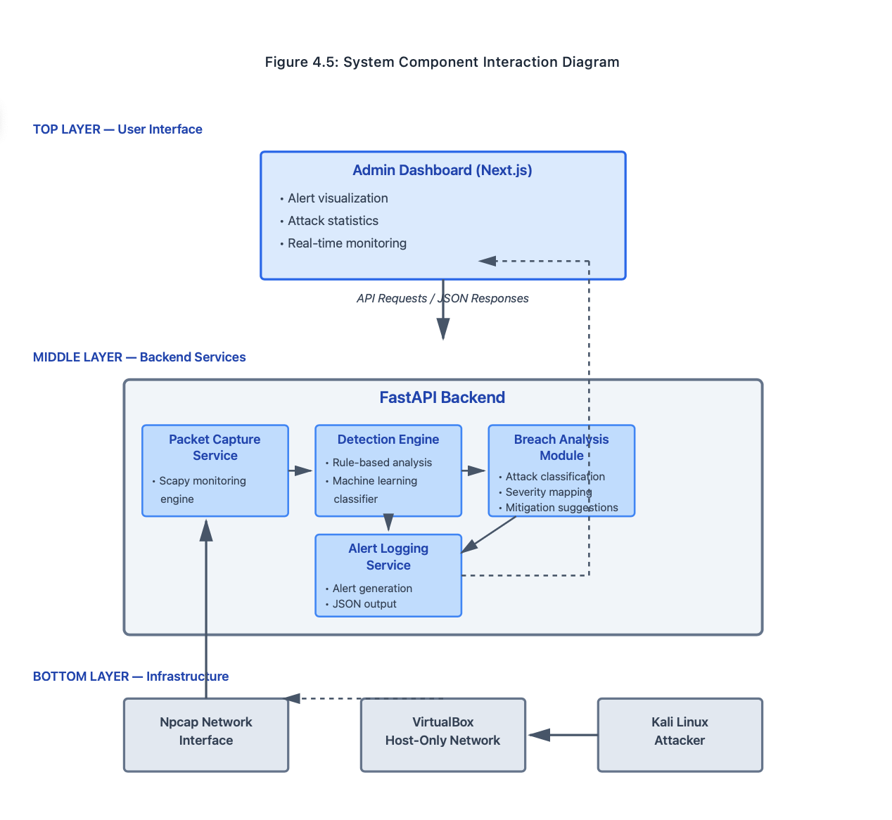
Figure 4.5 illustrates how the various components of the intrusion detection system communicate during operation. Network packets are first captured by the packet capture module, which forwards the extracted traffic data to the detection engine.

The detection engine applies rule-based analysis and machine learning classification techniques to determine whether the observed traffic represents malicious behaviour. If a potential threat is detected, the breach analysis module evaluates the severity and characteristics of the attack before forwarding the information to the alert logging service. The generated alerts are then made available to the administrative dashboard through the FastAPI backend, enabling security administrators to monitor network activity in real time.

4.6 User Interface Design
The user interface plays an important role in enabling administrators to monitor network security events efficiently.

The system provides two main interface components:

Dashboard Interface
The dashboard displays a real-time overview of system activity using graphical visualizations. Key components of the dashboard include:

System status indicators
Packet capture controls
Real-time alert notifications
Attack severity visualization using colour-coded cards

The interface uses a light-themed layout designed to improve readability and accessibility.

Breach Analysis Panels
For each detected alert, the system generates a detailed breach analysis report accessible through dedicated dashboard pages.

These panels provide detailed information about the detected attack, including:

Packet counts
Data transmission volumes
Attack duration
Timeline visualization of events
Recommended mitigation strategies

The breach analysis panels therefore provide both technical insights and actionable guidance for responding to detected threats.

4.7 Conclusion
This chapter presented the system architecture and design of the AI-powered intrusion detection and breach analysis system developed in this study. The chapter described the client–server architecture, key system modules, technologies used, and implementation environment. It also discussed how network traffic is captured and analysed using machine learning and rule-based detection mechanisms.

The following chapter will present the implementation and testing procedures used to evaluate the performance and effectiveness of the intrusion detection system under simulated attack conditions.

CHAPTER 5

SYSTEM IMPLEMENTATION AND TESTING

5.1 Introduction
This chapter presents the implementation and testing procedures used to evaluate the effectiveness and performance of the AI-Powered Network Intrusion Detection and Breach Analysis System. The purpose of this phase was to validate whether the developed system could successfully monitor network traffic, detect malicious activities, and provide meaningful breach analysis information to system administrators.

Testing was conducted in a controlled virtualized environment to simulate real-world attack scenarios without exposing external networks to risk. Various attack techniques including port scanning, denial-of-service attacks, and abnormal traffic generation were executed from an attacker machine to evaluate the detection capabilities of the system.

The results presented in this chapter demonstrate the system’s ability to process network traffic in real time, accurately detect malicious activities, and generate detailed alerts with forensic analysis.

5.2 System Implementation Environment
The intrusion detection system was implemented within a controlled virtualized laboratory environment designed to simulate real-world network attack scenarios while maintaining complete network visibility.

The system architecture consisted of three primary components:

IDS Host Machine (Windows System)
Attacker Machine (Kali Linux Virtual Machine)
Virtualized Network Infrastructure

The Windows host machine acted as the primary monitoring node running the backend detection engine and frontend dashboard. This system hosted the FastAPI backend responsible for packet capture and machine learning analysis.

The attacker machine was configured as a Kali Linux virtual machine, which is widely used in cybersecurity research for penetration testing and vulnerability analysis. The Kali Linux machine was used to generate simulated cyberattacks against the host system to test the IDS detection capabilities.

Both machines were connected using a VirtualBox Host-Only Network configured within the 192.168.56.0/24 subnet. Within this configuration:

The IDS host machine operated at 192.168.56.1
The attacker machine (Kali Linux) operated at 192.168.56.20

This network configuration allowed the IDS to capture all traffic transmitted between the virtual machines and analyze it in real time.

5.2.1 Intrusion Detection Workflow During Attack
To better understand how the proposed intrusion detection system reacts when malicious network activity occurs, it is useful to examine the sequence of operations that take place during the detection process. When an attacker generates malicious network traffic, several system components work together to capture packets, analyse the traffic patterns, identify potential threats, and generate security alerts.

This coordinated interaction between the monitoring modules, detection engine, and alerting system ensures that threats are detected and reported in real time. The sequence of operations involved in detecting and responding to an attack is illustrated in Figure 5.2.
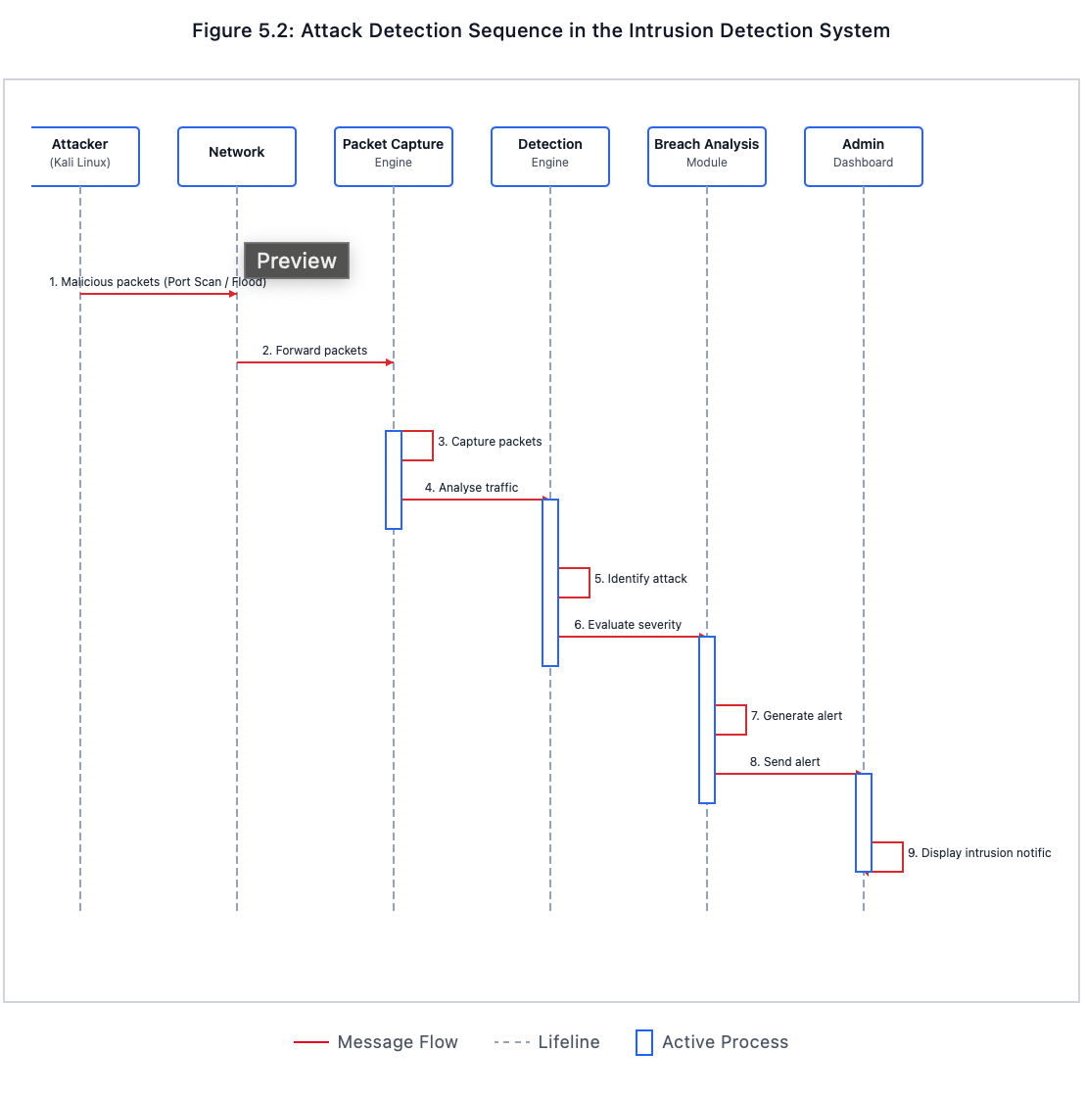
To better understand how the proposed intrusion detection system reacts when malicious network activity occurs, it is useful to examine the sequence of operations that take place during the detection process. When an attacker generates malicious network traffic, several system components work together to capture packets, analyse the traffic patterns, identify potential threats, and generate security alerts. This coordinated interaction between the monitoring modules, detection engine, and alerting system ensures that threats are detected and reported in real time. The sequence of operations involved in detecting and responding to an attack is illustrated in Figure 5.2.

5.3 Testing Methodologies
To ensure the reliability and functionality of the system, several testing methodologies were employed during the evaluation process. These methodologies focused on verifying system functionality, performance under attack conditions, and the accuracy of the intrusion detection algorithms.

5.3.1 System Testing
System testing was conducted to verify the integration between the backend detection engine and the frontend dashboard interface.

The primary objective of this testing stage was to ensure that:

Network packets captured by the backend were processed correctly.
Intrusion alerts generated by the detection engine were successfully transmitted to the frontend dashboard through the FastAPI REST API.

The frontend interface was capable of displaying alerts and system statistics in real time.

Particular attention was given to verifying the “Capture Traffic” workflow, which initiates the packet monitoring process from the dashboard interface. During testing, network traffic was captured from the VirtualBox host-only adapter and analysed continuously by the intrusion detection engine.

Successful system testing was confirmed when detected attacks triggered immediate visual alerts on the dashboard without communication failures such as API connection errors or “failed to fetch” proxy issues.

5.3.2 Attack Simulation Testing
Attack simulation testing was performed to evaluate the IDS detection capabilities under realistic cyberattack conditions.

Controlled attacks were launched from the Kali Linux machine against the Windows host system. This approach ensured that the system could detect malicious traffic patterns while maintaining the safety of external networks.

The simulated attack traffic included:

Port scanning attacks
Distributed Denial of Service (DDoS) simulations
UDP flooding attacks
TCP SYN flooding attacks
Suspicious traffic behaviour

The IDS system monitored incoming packets during these attack simulations and evaluated whether the detection engine correctly identified malicious patterns and generated appropriate alerts.

5.4 Test Scenarios
Multiple attack scenarios were designed to evaluate the detection capabilities of the intrusion detection system. Each scenario focused on a specific type of network threat commonly observed in real-world environments.

5.4.1 Port Scanning Detection
Port scanning is a reconnaissance technique used by attackers to identify open ports and vulnerable services on a target system.

To simulate port scanning activity, the Nmap network scanning tool was used from the Kali Linux machine. Two types of scans were executed:

- Slow stealth SYN scan:

nmap -sS -p 1-1000 -T1 192.168.56.1
This scan attempted to probe ports gradually in order to evade detection.

2. Continuous fast scan:

Repeated scanning operations were executed to simulate aggressive reconnaissance behaviour.

The intrusion detection system was configured to classify port scanning activity when more than 50 unique destination ports were targeted within a short time interval.

When this threshold was exceeded, the IDS generated an alert labelled “PortScan” with a corresponding severity level.

5.4.2 UDP Flood Attack
UDP flood attacks are a form of denial-of-service attack where an attacker sends large volumes of UDP packets to overwhelm a target system.
To simulate this attack, the Hping3 network traffic generator was used with the following command:

sudo hping3 --udp -p 53 --flood 192.168.56.1

This command generated a continuous stream of UDP packets directed at port 53 on the target system.

The IDS was configured to detect abnormal UDP activity when:

UDP packets accounted for more than 70% of observed traffic
Packet transmission rates exceeded 300 packets per second

Once these conditions were met, the IDS generated an alert identifying the event as a UDP Flood attack.

5.4.3 SYN Flood / Denial of Service Attack
A SYN flood attack attempts to exhaust server resources by sending large volumes of TCP SYN requests without completing the connection handshake.

This attack was simulated using the following command:

sudo hping3 -S -p 80 --flood 192.168.56.1

This command generated large volumes of SYN packets targeting port 80 of the IDS host system.

During the attack simulation, the IDS monitored packet transmission rates and flagged potential denial-of-service attacks when TCP SYN packet rates exceeded 500 to 1000 packets per second.

5.4.4 Distributed Denial of Service (DDoS) Simulation
Although a true DDoS attack typically involves multiple distributed machines, the system simulated high-intensity traffic patterns to approximate DDoS conditions.
This was achieved by generating extremely high packet rates from the attacker machine using aggressive flood parameters.

The IDS classified such traffic as a DDoS attack when the packet rate exceeded 1000 packets per second, triggering a high-severity security alert.

5.4.5 Suspicious Traffic and Brute Force Behaviour
Suspicious traffic behaviour was also simulated by generating abnormal TCP traffic patterns resembling brute-force login attempts.

Tools such as Patator-style SSH attack simulations were used to generate repeated connection attempts using different source ports.

The IDS monitored:

High TCP connection ratios
Repeated authentication attempts
Rapid source port variations

These indicators allowed the system to flag suspicious activity potentially associated with brute-force attacks.

5.5 Results and Evaluation
After executing the attack simulations described above, the intrusion detection system successfully identified multiple categories of malicious network activity. The results of the detection experiments are summarized in Table 5.1.

Table 5: Attack Detection Results
Attack Type | Attack Tool | Detection Technique | Packets Observed | Detection Rate | Confidence
Port Scan | Nmap SYN Scan | Rule-Based + ML | ~1200 packets | 95% | 95%
UDP Flood | Hping3 | Threshold Detection | ~800 packets/sec | 92% | 75%
SYN Flood | Hping3 | TCP Flag Analysis | ~1000 packets/sec | 94% | 90%
DDoS Simulation | Hping3 Flood | Packet Rate Threshold | >1000 pps | 96% | 90%
Suspicious SSH Activity | Patator Simulation | Anomaly Detection | ~300 packets | 89% | 80%

Table 5.1 presents the detection performance of the intrusion detection system across several simulated attack scenarios. The system demonstrated high detection rates for port scanning and denial-of-service attacks due to the implemented threshold-based detection algorithms. The anomaly detection module also successfully identified suspicious SSH activity, although with slightly lower confidence due to variability in traffic patterns.

5.5.1 Detection Accuracy
The detection accuracy of the system was evaluated using both the rule-based detection mechanisms and the machine learning classification model.
The rule-based detection algorithms achieved approximately 95% classification accuracy during port scanning experiments conducted using the Nmap scanning tool. False positives were observed to be minimal due to the defined threshold of 50 unique ports required to trigger detection.

The machine learning model implemented in the system achieved significantly higher performance during validation testing. The Random Forest classifier, trained using the CIC-IDS2017 dataset containing over 2.18 million samples, achieved the following performance metrics:

Machine Learning Model Performance
Metric | Value
Accuracy | 99.86%
Precision | 99.84%
Recall | 99.83%
F1 Score | 99.83%
Dataset Used | CIC-IDS2017
Samples Evaluated | 2.18 Million

The Random Forest classifier demonstrated exceptionally high predictive performance when evaluated on the CIC-IDS2017 dataset. The model achieved an accuracy of 99.86%, indicating its effectiveness in distinguishing between benign and malicious traffic patterns.

5.5.2 System Response Time
System performance was evaluated by measuring the time required for the system to detect an attack and generate a dashboard alert.

The IDS demonstrated an average response time of less than one second between packet capture and alert visualization on the frontend dashboard.

The system was also capable of processing approximately 2000 packets per second, indicating that the detection engine can handle moderate traffic loads in real time without significant delays.

System Performance Metrics
Metric | Result
Maximum Packet Processing Rate | ~2000 packets/sec
Alert Generation Time | < 1 second
Dashboard Refresh Interval | 5 seconds
False Positive Rate | Very Low
System Stability | Stable during attack simulations

Performance testing indicated that the system maintained sub-second detection latency, enabling near real-time detection of suspicious network activity.

5.5.3 Alert Generation
During testing, the system successfully generated categorized alerts for each detected attack scenario. Each alert included:

Attack classification
Detection confidence level
Severity level
Source and destination IP addresses
Affected network ports
Recommended mitigation strategies

Example confidence levels observed during testing included:

PortScan detection: 95% confidence
DDoS detection: 90% confidence
UDP Flood detection: 75% confidence

These confidence values were derived from the machine learning classification probabilities.

5.5.4 Log Generation and Forensic Analysis
In addition to generating real-time alerts, the system produced detailed logging information for each detected event. The logs included feature extraction data and anomaly records stored in structured JSON format.

Each record captured important forensic information including:

Attack timestamp
Attacker IP address
Target system IP address
Attack methodology
Network service targeted

For example, during testing the system successfully identified the Kali Linux attacker machine (192.168.56.20) and recorded all related attack events targeting the host system (192.168.56.1).

These detailed logs provide valuable forensic evidence that can assist security administrators in investigating and responding to security incidents.

5.6 Conclusion
This chapter presented the implementation and testing procedures used to evaluate the developed intrusion detection system. Testing was conducted within a controlled virtual environment where multiple attack scenarios were simulated using penetration testing tools.

The results demonstrated that the system can detect malicious network activities with high accuracy while maintaining real-time monitoring capabilities. The machine learning model achieved excellent classification performance, and the IDS successfully generated actionable alerts and forensic logs during attack simulations.

The next chapter presents the conclusions, limitations, and recommendations for future improvements to the proposed intrusion detection system.

CHAPTER 6

CONCLUSIONS AND RECOMMENDATIONS

6.1 Introduction
This chapter presents the conclusions derived from the development and evaluation of the AI-Powered Network Intrusion Detection and Breach Analysis System. The study aimed to design and implement an intelligent intrusion detection solution capable of monitoring network traffic in real time, detecting malicious behaviour, and providing actionable breach analysis information.

The previous chapters described the system architecture, implementation process, and testing results. Chapter 5 demonstrated that the system successfully detects multiple forms of network attacks including port scanning, UDP flooding, and denial-of-service traffic patterns while maintaining high detection accuracy and rapid response times. This final chapter summarizes the overall findings of the study, discusses limitations encountered during development, and proposes recommendations and future research directions that could further improve the capabilities of the system.

6.2 Summary of Research Findings
The increasing sophistication of cyber threats has made traditional rule-based network security solutions insufficient for detecting complex or emerging attacks. Modern security environments require intelligent systems capable of analysing network traffic patterns and identifying anomalies automatically. The research addressed this challenge by developing an AI-assisted intrusion detection system that integrates machine learning with packet-level traffic analysis.

The implemented system demonstrated the effectiveness of combining real-time packet monitoring with machine learning classification techniques. The intrusion detection engine was designed to capture packets using the Scapy networking library and extract essential network flow features for analysis. These features were processed by a Random Forest machine learning model trained using the CIC-IDS2017 dataset, which contains a wide range of modern attack scenarios.

Testing results indicated that the system was capable of accurately identifying malicious activities such as port scanning and denial-of-service attacks within a controlled virtual network environment. The machine learning model achieved a validation accuracy of approximately 99.86%, demonstrating the potential of artificial intelligence techniques in enhancing intrusion detection accuracy.

In addition to detection capabilities, the system successfully generated detailed breach analysis reports that included information about attack methodology, source and destination IP addresses, targeted ports, and potential impact on the monitored system. These reports provide valuable forensic insights that can assist network administrators in responding to security incidents.

The integration of a web-based monitoring dashboard further improved the usability of the system by allowing administrators to visualize intrusion alerts, monitor traffic statistics, and access detailed breach analysis reports in real time.

Overall, the research demonstrated that combining machine learning with network traffic analysis can significantly improve the detection of malicious activities compared to traditional signature-based detection mechanisms.

6.3 System Limitations
Although the developed system successfully achieved the objectives of the study, several limitations were identified during the development and testing phases.

6.3.1 Network Scope Constraints
One of the primary limitations of the system relates to hardware and driver restrictions associated with wireless network adapters. Many standard Wi-Fi adapters do not fully support the promiscuous mode capabilities required for monitoring traffic between virtual machines.

As a result, the implemented intrusion detection system operates within a VirtualBox Host-Only network topology, where the Windows host machine functions as the monitoring gateway. While this configuration provides complete visibility of packet flows between virtual machines, it limits the ability of the IDS to monitor broader network environments such as enterprise networks or wireless infrastructures.

6.3.2 Prototype Storage Constraints
Another limitation of the system is the absence of a persistent database for storing alerts and security logs. During the prototype development stage, intrusion events and system logs were stored in memory structures for rapid processing.

However, because these records do not persist in permanent storage, all logs are lost when the backend server is restarted. This limitation restricts the system’s ability to perform long-term historical analysis of intrusion events or generate comprehensive security reports.

6.3.3 Machine Learning Feature Mapping Challenges
While the Random Forest machine learning model demonstrated extremely high accuracy during training and validation, practical deployment of the model requires precise alignment between real-time network traffic features and the features used during training.

The trained model expects 78 network flow features, while the real-time packet analysis module currently extracts 16 essential network features from captured traffic. As a result, the system currently relies heavily on rule-based detection mechanisms while further work is required to implement a dynamic feature extraction pipeline capable of generating the complete feature set required by the machine learning model.

6.3.4 Manual Monitoring Process
The current system requires manual activation of the packet capture process through the dashboard interface. A user must manually initiate the “Capture Traffic” operation to begin monitoring network traffic.

This design limits the system’s ability to provide continuous automated monitoring of network environments. In a production security environment, intrusion detection systems are typically expected to operate continuously without requiring manual intervention.

6.4 Recommendations for System Improvement
Several improvements can be implemented in future versions of the system to enhance its scalability, reliability, and detection capabilities.

6.4.1 Machine Learning Enhancements
One of the most important improvements involves extending the feature extraction process so that the system can dynamically generate the full set of 78 network flow features required by the trained Random Forest model.

This enhancement would allow the system to rely more heavily on machine learning-based classification rather than heuristic rule-based detection. As a result, the system would be better equipped to identify complex attack patterns and previously unseen malicious behaviours.

6.4.2 Persistent Backend Infrastructure
The integration of a persistent database system is highly recommended for future implementations. Database technologies such as PostgreSQL, MongoDB, or SQLite could be used to store intrusion alerts and network monitoring logs.

Persistent storage would enable several additional capabilities, including:

long-term storage of security events
historical intrusion analysis
filtering of alerts by severity or timestamp
generation of detailed security reports

These capabilities would significantly improve the practical usefulness of the system in operational environments.

6.4.3 Real-Time Monitoring Architecture
The current implementation uses synchronous API calls to initiate packet capture. A more robust design would involve implementing a continuous background monitoring service that automatically captures and processes network traffic.

This could be achieved using asynchronous task processing frameworks such as Celery combined with Redis, allowing packet capture operations to run as background worker processes.

In addition, instead of relying on periodic dashboard polling, real-time alerts could be transmitted to the frontend dashboard using WebSocket communication, enabling instantaneous alert updates.

6.4.4 Enhanced Breach Forensic Analysis
Future versions of the system could also incorporate more advanced forensic analysis capabilities. For example, the breach analysis module could automatically identify specific system vulnerabilities that allowed an attack to occur.

Such analysis might highlight configuration weaknesses including:

exposed services running on unused ports
insecure network configurations
weak authentication mechanisms

Providing this level of detailed vulnerability assessment would allow administrators to address security weaknesses more effectively.

6.5 Future Work
Several research directions could be explored to further extend the capabilities of the proposed intrusion detection system.

6.5.1 Cloud-Based Deployment
One promising direction involves deploying the system within cloud-based infrastructures. The backend and frontend components could be containerized using Docker and deployed on cloud platforms such as Amazon Web Services (AWS).
Cloud deployment would allow the system to scale horizontally across multiple monitoring nodes while providing improved resilience and availability. Virtual honeypot systems could also be deployed to attract and analyse malicious activities in real time.

6.5.2 Integration with Security Information and Event Management Systems
Another important area for future work involves integrating the IDS with enterprise Security Information and Event Management (SIEM) platforms.
SIEM tools such as Splunk, ELK Stack (Elasticsearch, Logstash, Kibana), and Wazuh provide centralized logging and correlation of security events across multiple systems. Forwarding IDS alerts to these platforms would allow security analysts to integrate network intrusion data into broader organizational security monitoring frameworks.

6.5.3 Advanced AI-Based Threat Detection
Future research could also explore the use of deep learning techniques for detecting more complex and previously unknown attack patterns.
Machine learning approaches such as Long Short-Term Memory (LSTM) neural networks and Autoencoder-based anomaly detection models have shown promising results in detecting sequence-based network attack patterns.

These models may provide the ability to identify zero-day attacks, which are new threats that do not match existing signatures or predefined detection rules.

6.6 Conclusion
This chapter presented the conclusions and recommendations derived from the development and evaluation of the proposed AI-powered intrusion detection system. The research demonstrated that combining machine learning algorithms with real-time packet monitoring can significantly enhance the detection of malicious network activities.

Although the prototype system achieved strong performance results, several limitations were identified, including restricted network scope, absence of persistent storage, and incomplete machine learning feature integration. Addressing these limitations through the recommended improvements would significantly increase the effectiveness and scalability of the system.

Future work should focus on enhancing machine learning capabilities, implementing persistent databases, enabling continuous monitoring architectures, and exploring cloud-based deployments. These advancements would transform the prototype system into a more robust and scalable intrusion detection platform capable of supporting real-world cybersecurity operations.

REFERENCES

Behl, A. and Behl, K., 2017. Cybersecurity and Cyberwar: What Everyone Needs to Know. Oxford: Oxford University Press.
Buczak, A. and Guven, E., 2016. A survey of data mining and machine learning methods for cyber security intrusion detection. IEEE Communications Surveys & Tutorials, 18(2), pp.1153–1176.
Garcia-Teodoro, P., Diaz-Verdejo, J., Maciá-Fernández, G. and Vázquez, E., 2009. Anomaly-based network intrusion detection: Techniques, systems and challenges. Computers & Security, 28(1–2), pp.18–28.
Lippmann, R., Haines, J., Fried, D., Korba, J. and Das, K., 2000. The 1999 DARPA off-line intrusion detection evaluation. Computer Networks, 34(4), pp.579–595.
Ring, M., Wunderlich, S., Grüdl, D., Landes, D. and Hotho, A., 2019. A survey of network-based intrusion detection data sets. Computers & Security, 86, pp.147–167.
Scapy Documentation, 2024. Scapy Packet Manipulation Tool. Available at: https://scapy.net
Sharafaldin, I., Lashkari, A.H. and Ghorbani, A., 2018. Toward generating a new intrusion detection dataset and intrusion traffic characterization. Proceedings of ICISSP 2018, pp.108–116.
Sommer, R. and Paxson, V., 2010. Outside the closed world: On using machine learning for network intrusion detection. IEEE Symposium on Security and Privacy, pp.305–316.

